|  |
| --- |
| **cage** |

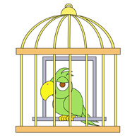A lion has escaped from its cage.  
Using a bunch of bananas, the zoo-keeper persuaded the monkey back into its cage.  
The gorilla rattled the bars of its cage.

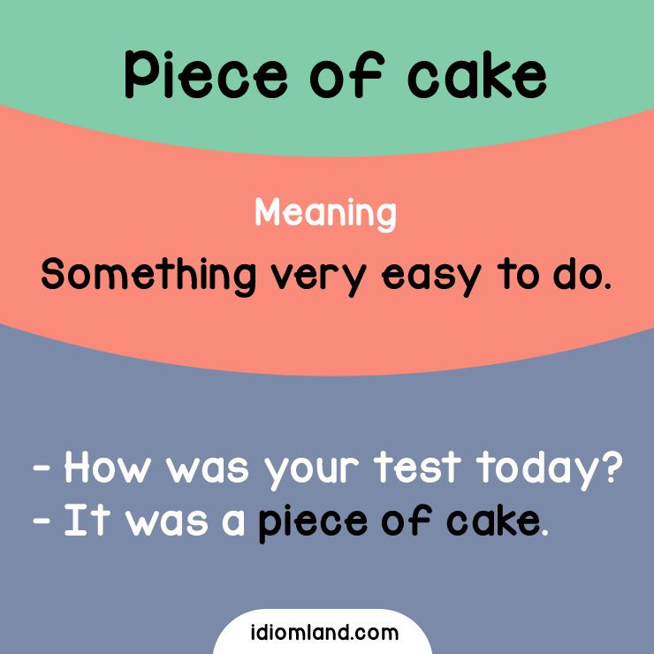

|  |
| --- |
| **cake** |

He cut the cake into six pieces and gave each child a slice.  
Is there any of that lemon cake left?  
Bake the cake in a hot oven, about 220°C, for 30 minutes.  
The exam was a piece of cake.

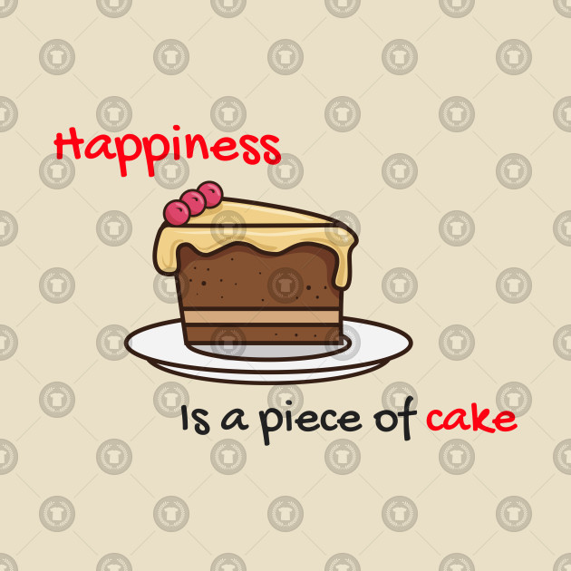

|  |
| --- |
| **calculator** |

The children are taught to use calculators from a young age.  
Candidates may use electronic calculators in the exam.

|  |
| --- |
| **calendar** |

She needs to check his calendar and see what he was doing in the summer of 2010.



|  |
| --- |
| **call** |

They've called the twins Edward and Thomas.  
His real name is Jonathan, but they've always called him Johnny.  
What's her new novel called?  
I think he was called Blake, if I remember correctly.  
Do you think we should call the police?

|  |
| --- |
| **call off :  cancel** |

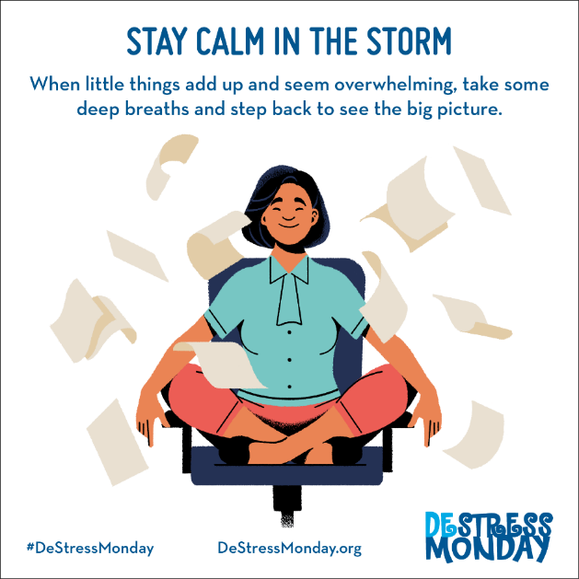The police have called off the search for the missing child until dawn tomorrow.

|  |
| --- |
| **calm** |

I was extremely angry but I'm feeling a little calmer now.  
The pilot said we’d have to make an emergency landing, and the flight attendants tried to keep us calm.  
I tried to stay calm and just ignore him.  
Keep calm and try not to panic.

|  |
| --- |
| **camel** |

The wild camel is more endangered than the giant panda.



|  |
| --- |
| **campaign** |

The protests were part of their campaign against the proposed building development in the area.  
This is the latest act of terrorism in a long-standing and bloody campaign of violence.  
The endless public appearances are an inevitable part of an election campaign.  
We've received a lot of expressions of support for our campaign.  
The campaign is aimed specifically at young people.

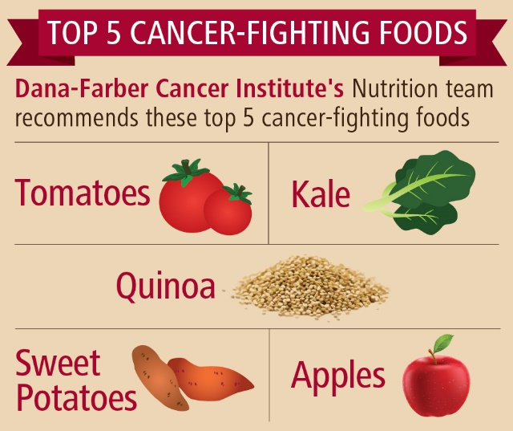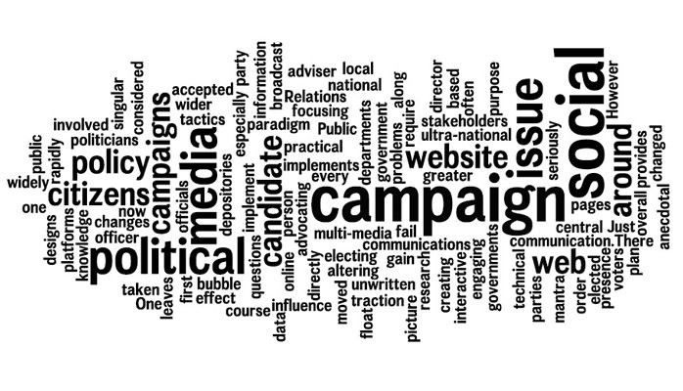

|  |
| --- |
| **cancel : call off** |

She had to cancel her dental appointment.

|  |
| --- |
| **cancer** |

He died of liver cancer.  
There's still no cure for cancer.  
He died last week after a long fight with cancer.

|  |
| --- |
| **candidate** |

There are three candidates standing in the election.  
Candidates must write their names on the top page of the exam paper.  
As a candidate country, Turkey needs to adapt a considerable part of its national legislation in line with EU law.



|  |
| --- |
| **capable** |

We need to get an assistant who's capable and efficient.  
Lord himself was a capable but not an outstanding player.  
They've got a very capable lawyer working on the case.



|  |
| --- |
| **per capita** |

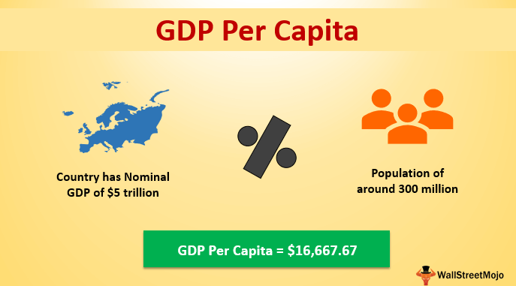**for or by each person**

Japanese visitors’ spending per capita was much higher than average spending by tourists from other countries.  
The US uses twice as much oil per capita as European competitors.

|  |
| --- |
| **capital** |

Australia's capital city is Canberra.  
London used to be the financial capital of the world.

|  |
| --- |
| **captivate** |

***to attract someone very much, and hold their attention***  
He was captivated by her beauty and smile.  
With her beauty and charm, she captivated film audiences everywhere.

|  |
| --- |
| **capture** |

Government troops have succeeded in capturing the rebel leader.  
The town was captured after a siege lasting ten days.  
The Dutch fleet captured two English ships.  
Two of the soldiers were killed and the rest were captured.  
Rebel forces captured the city after a week-long battle.

|  |
| --- |
| **car** |

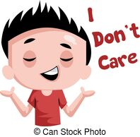You should always check your oil, water and tyres before taking your car on a long trip.  
She doesn't have a car.  
Where did he park his car?

|  |
| --- |
| **care** |

They shared the care of the children.  
The government has put a lot more money into health care.  
The standard of care at our local hospital is excellent.

I really don't care whether we go out or not.  
I don't care how much it costs, just buy it.

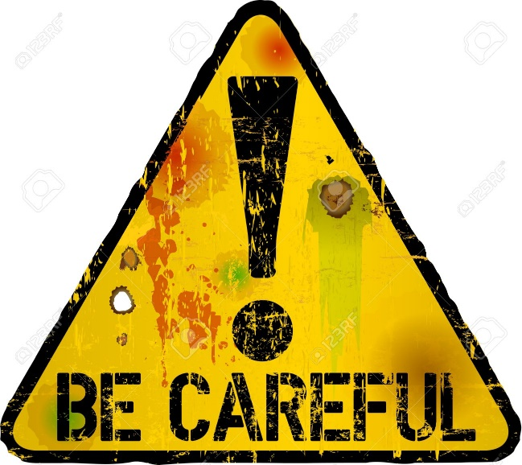

|  |
| --- |
| **careful *≠ careless*** |

Michael is a very careful worker.  
After careful consideration of your proposal, I regret to say that we are unable to accept it.  
Be careful with the glasses.  
Be careful where you put that hot pan.

|  |
| --- |
| **careless *≠careful*** |

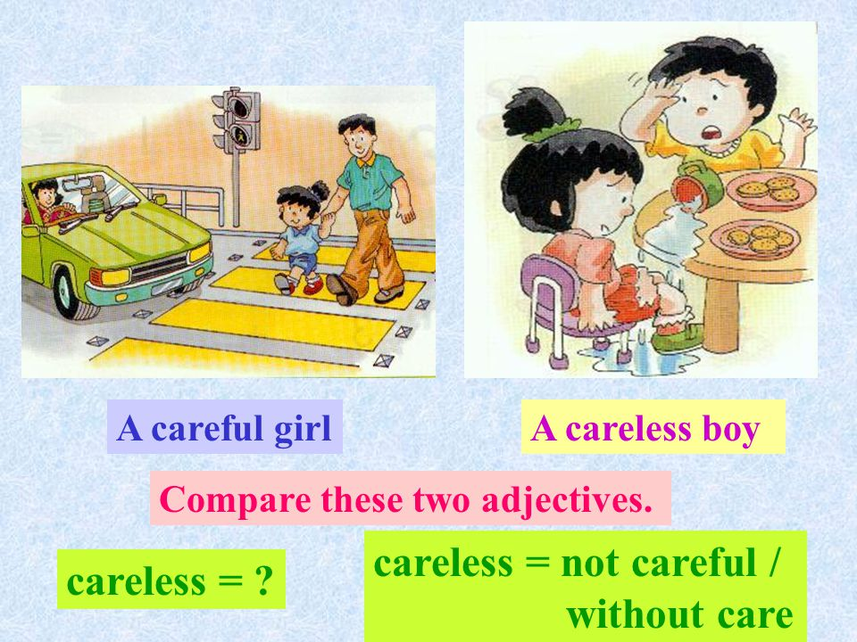He's very careless with his money.  
His work is full of careless mistakes.  
My son's teacher says that his work is often rather careless.

|  |
| --- |
| **carpet** |

I spilled red wine on their cream carpet.  
We've taken the carpet up and exposed the floorboards.  
He was busy hoovering the bedroom carpet when I got home.  
We need to carpet the stairs.

|  |
| --- |
| **carrot** |

Do rabbits really love carrots?  
While the rabbit-carrot connection is squarely at the center of pop culture, carrots aren't the ideal food source for rabbits.  
The sight of Bugs Bunny chewing a carrot is among the best–known images in cartoon history, but root vegetables are in fact bad for rabbits.

|  |
| --- |
| **carry out** |

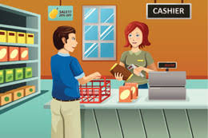The hospital is carrying out tests to find out what's wrong with her.  
I'm only carrying out my orders/instructions.  
She arrived to carry out a health and safety inspection of the building.  
His orders were carried out to the letter.  
That company does not carry out tests on animals.

|  |
| --- |
| **cashier /keşiyır/** |

She was once dismissed from her job as head cashier with a supermarket chain on suspicion of embezzlement.

|  |
| --- |
| **castle** |

We visited an ancient ruined castle overlooking the sea.  
In addition to his flat in London, he has a villa in Italy and a castle in Scotland.

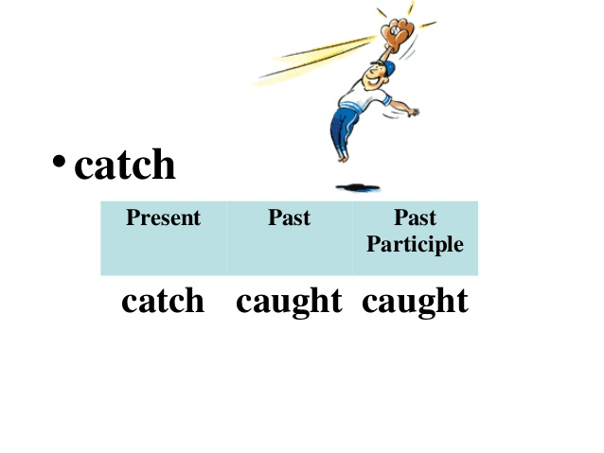

|  |
| --- |
| **catch** |

Two armed men were caught trying to cross the frontier at night.  
They were happy because they had caught a lot of fish that day.  
I can see you're busy right now, so I'll catch you (= speak to you) later.

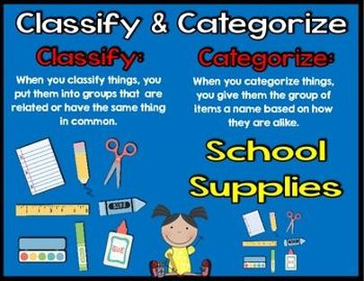

|  |
| --- |
| **categorize** |

*to put people or things into groups with the same features:*

The books are categorized into beginner and advanced.  
I would categorize this as a very early example of Tudor art.

|  |
| --- |
| **cause  : reason** |

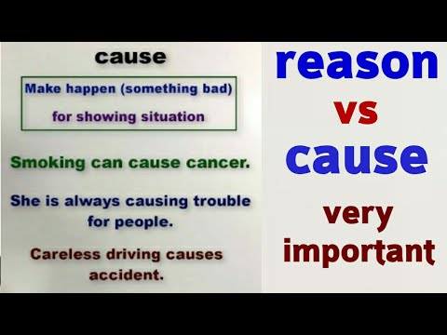The police are still trying to establish the cause of the fire.  
She had died of natural causes.

I hope the children haven't caused you too much trouble.  
I didn't mean to cause you any trouble.

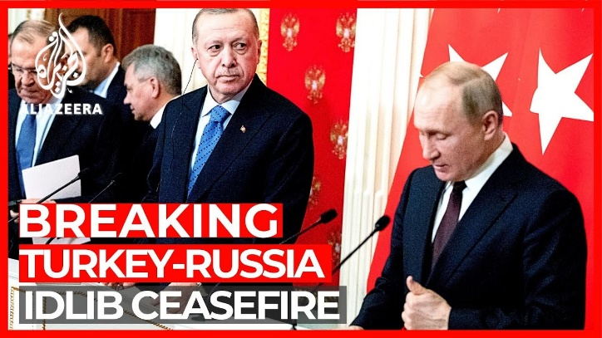

|  |
| --- |
| **ceasefire** |

They have called a temporary ceasefire in the region.  
The government had failed in numerous attempts to achieve a ceasefire through negotiation.  
The ceasefire came into effect throughout the country at midnight.

|  |
| --- |
| **ceiling** |

The kitchen ceiling needs painting.  
Windows were shattered and ceilings cracked in several nearby towns.

|  |
| --- |
| **cemetery** |

A cemetery is a place in which dead bodies and cremated remains are buried.

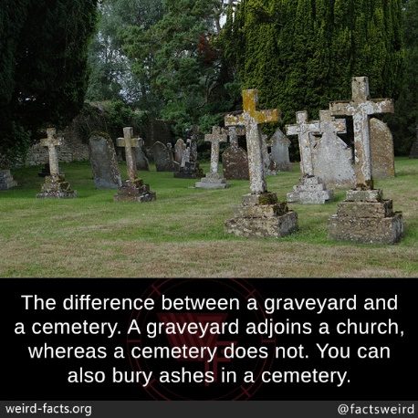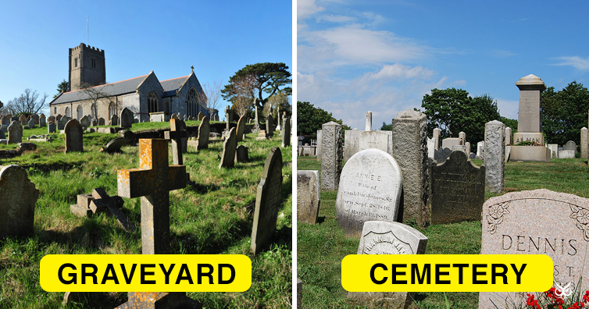

|  |
| --- |
| **century** |

Life in the 19th century was very different from what it is now.  
She was probably the most highly educated prime minister of this century.  
The church was built in the 13th century.

|  |
| --- |
| **chain** |

D&R has built up a chain of 180 bookshops across the country.  
The gates were locked with a padlock and a heavy steel chain.  
Put the chain on the door if you are alone in the house.  
Songül was wearing a beautiful silver chain around her neck.  
The well-known fast-food chain has expanded to over 20,000 restaurants in 17 countries.

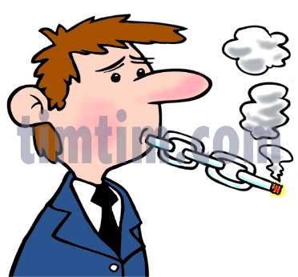

|  |
| --- |
| **chain smoker** |

Chain smoking is the practice of lighting a new cigarette after one that is finished.  
He is a chain smoker.

|  |
| --- |
| **chair** |

The coat was thrown over the back of the chair.  
She slumped into the chair, exhausted.

Who will take the chair at the next meeting?  
All questions should be addressed to the chair.  
She is the chair of the board of governors at a local school.  
We need a chair for Ian - could you get one from the other room?  
Would you like to chair tomorrow's meeting?

|  |
| --- |
| **challenge** |

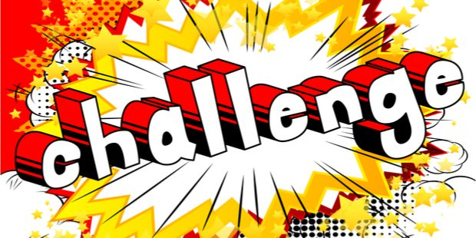Finding a solution to this problem is one of the greatest challenges faced by scientists today.  
You know me - I like a challenge.  
Finding a cure for cancer is one of the biggest challenges facing medical researchers.  
I've promised to finish the task by Friday, but it's going to be quite a challenge.

|  |
| --- |
| **challenging** |

He resigned from the company in order to take a more challenging job.  
It's when you find yourself in a really challenging situation that you find out what you are capable of.  
The year ahead will be challenging for us all.

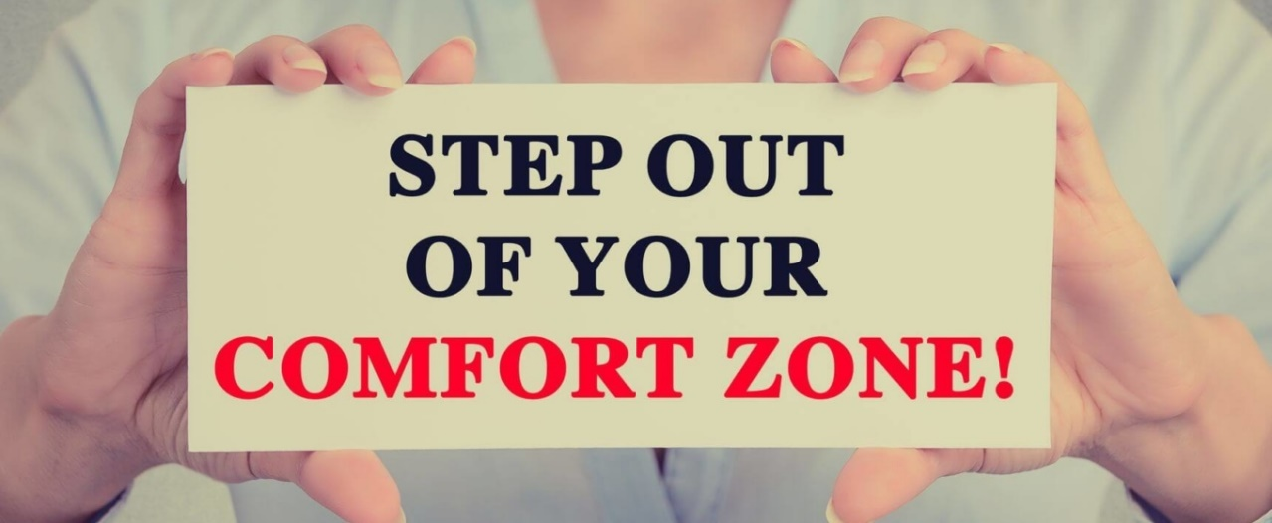

|  |
| --- |
| **change** |

Susan has changed a lot since I last saw her.  
Changing your eating habits is the best way to lose weight.  
The leaves on trees change colour in the autumn.

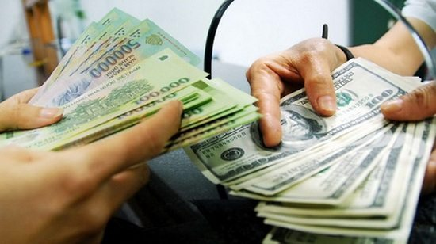  
Three boys were changing a tyre by the side of the road.  
I bought these gloves for my daughter, but they’re too large. Can I change them for a smaller size?  
The car needs an oil change.  
There was a sudden change in the weather.

I want to change my dollars into pesos, please.  
Can you change a £20 note? Can you make change for $20?  
I have about a dollar in change.

|  |
| --- |
| **chant** |

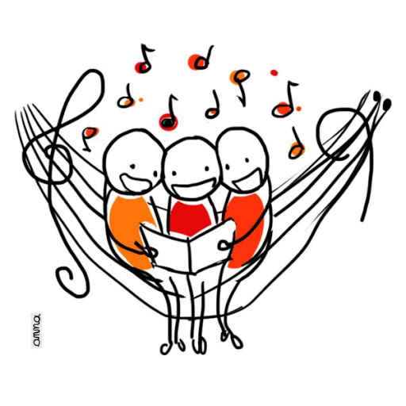***to repeat a word or phrase again and again***  
protesters chanting anti-government slogans  
Protesters clapped and chanted.

***to sing or say a religious song or prayer in a way that involves using only one note or tone***  
We could hear monks chanting as we entered the monastery.

|  |
| --- |
| **chaos  /keyas/** |

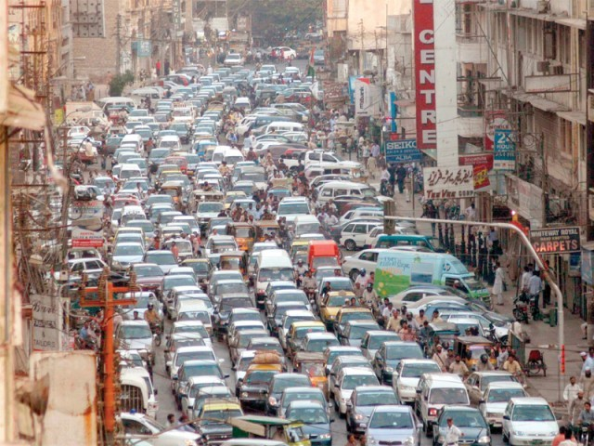Our house is in complete chaos at the moment.  
There was chaos in the theatre when the bomb went off.  
Computer failure has created chaos in the passport office.  
Snow and ice have caused chaos on the roads.  
Ever since our secretary walked out, the office has been in a state of chaos.

|  |
| --- |
| **chaotic /keyotik/** |

***a chaotic situation is one in which everything is happening in a confused way***  
We flew on the day after Christmas and the situation at the airport was completely chaotic.  
The house is a bit chaotic at the moment - we've got all these extra people staying and we're still decorating.  
He's a chaotic sort of a person - always trying to do twenty things at once.

|  |
| --- |
| https://tr.newworldai.com/wp-content/uploads/2019/12/chapter-8.jpg**chapter** |

Read Chapter 10 before class tomorrow.  
This chapter is so difficult to digest, I shall have to read it again later.  
The first chapter describes the strange sequence of events that lead to his death.  
The period before the revolution is an interesting chapter in British history.  
That chapter of my life closed when I had a serious riding accident.

|  |
| --- |
| **charge**: ücretlendirme |

He charged me twenty bucks for this carpet.  
There will be an extra charge for any additional passengers.

|  |
| --- |
| **charge with:** suçlamak |

*(of the police) to make a formal statement saying that someone is accused of a crime:*

She's been charged with murder.  
She is charged  **with** murder**ing** her husband.

|  |
| --- |
| **charity** |

***an organization that gives money, goods, or help to people who are poor, sick etc.***  
Several charities sent aid to the flood victims.  
All the money raised by the concert will go to charity.  
I like to give a small amount of what I earn to charity.  
Give your old clothes to a charity shop.  
She does a lot of work for charity.  
People tend to give to (= give money to) charity at Christmas time.

|  |
| --- |
| **chat: have conversation** |

We were just chatting about what we did last weekend.  
Why don't you give me a call and we'll have a chat?

|  |
| --- |
| **cheat** |

He cheats at cards?  
He cheated in the test by copying from the boy in front.  
The winner has been disqualified for cheating, so justice has been done .

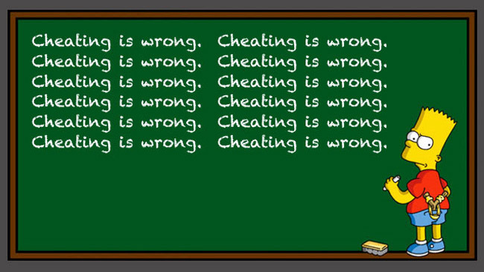

|  |
| --- |
| **cheese** |

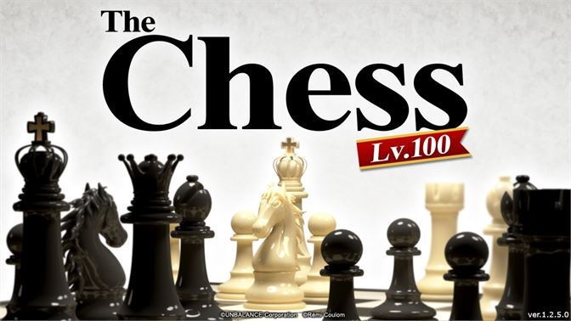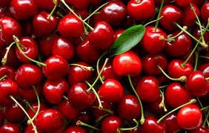Would you like a slice/piece of cheese with your bread?  
goat's cheese  
You need 250 grams of grated cheese for this recipe.

|  |
| --- |
| **cherry** |

The cherry tree is beginning to blossom.  
I had a cherry flavoured drink.

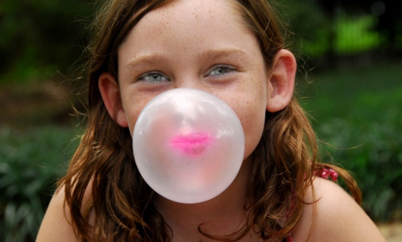

|  |
| --- |
| **chess** |

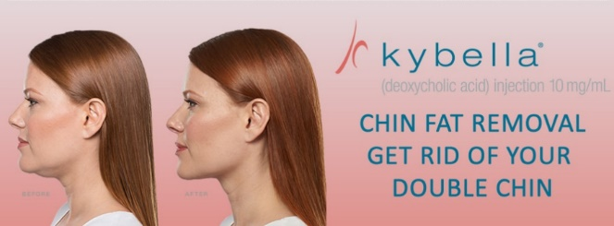I'm not conversant with the rules of chess.  
She's quite a hotshot *(someone who is skillful and successful at something:)* at chess.  
In chess, the pieces can only move in certain directions.  
If you want to get anywhere in chess, you have to study the various openings.  
*(****the beginning of a game of chess: opening)***

|  |
| --- |
| **chew** |

Would you like some a piece/stick of chewing gum to chew?  
This meat is difficult to chew.

|  |
| --- |
| **chewing gum** |

Would you like a piece/stick of chewing gum?  
I've got chewing gum stuck on my shoe.  
Can I have a piece of chewing gum?

|  |
| --- |
| **chin** |

He rubbed his chin thoughtfully.  
Graham came back from holiday with a week's growth of beard on his chin.

|  |
| --- |
| **Chin up!** |

Chin up! It'll soon be the weekend.  
Chin up! It’ll be over soon.

|  |
| --- |
| **choice** |

It's your choice..  
There wasn't much choice on the menu.  
He had no choice but to accept.

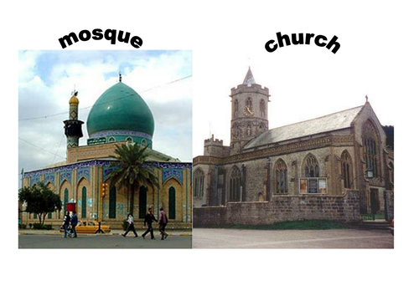

|  |
| --- |
| **choose** |

She had to choose between the two men in her life.  
It's difficult choosing where to live

|  |
| --- |
| **church** |

They built the church on the edge of the village.  
The bride and groom posed for pictures outside the church.

|  |
| --- |
| **cigar** |

Cigar smoking is often considered less dangerous than cigarette smoking, but this isn't true.

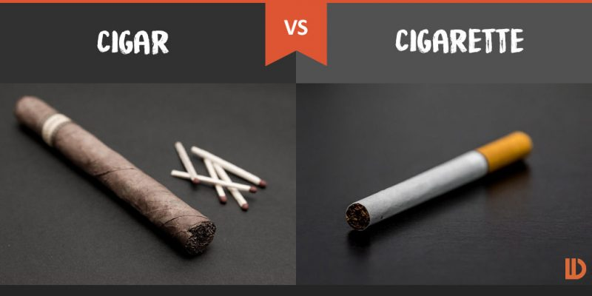

|  |
| --- |
| **cigarette** |

I need a packet of cigarettes.  
She lit a cigarette.

|  |
| --- |
| **civilization** |

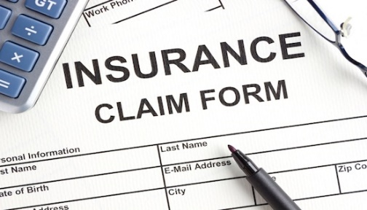Some people think that nuclear war would mean the end of civilization.  
Many different civilizations have left their mark on the country and its culture.

|  |
| --- |
| **claim** |

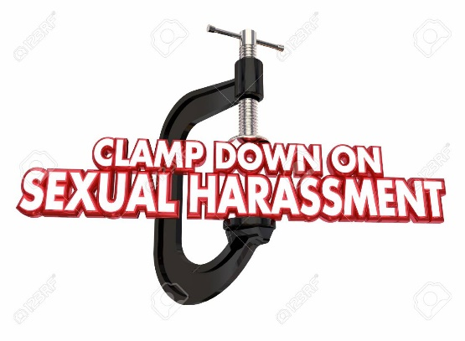The company claims (that) it is not responsible for the pollution in the river.  
He claims to have met the president, but I don't believe him.  
All parties have claimed success in yesterday's elections.  
An unknown terrorist group has claimed responsibility for this morning's bomb attack.  
The product claims that it can make you thin without dieting.  
He claims that he didn’t see anything.

|  |
| --- |
| **clamp down on sth** |

**to take strong action to stop or limit a harmful or unwanted activity:**  
The government is clamping down on teenage drinking.

**to stop or limit an activity or the people doing it, esp. a bad or illegal activity:**  
Stores use electronic devices to clamp down on theft.

|  |
| --- |
| **clarity** |

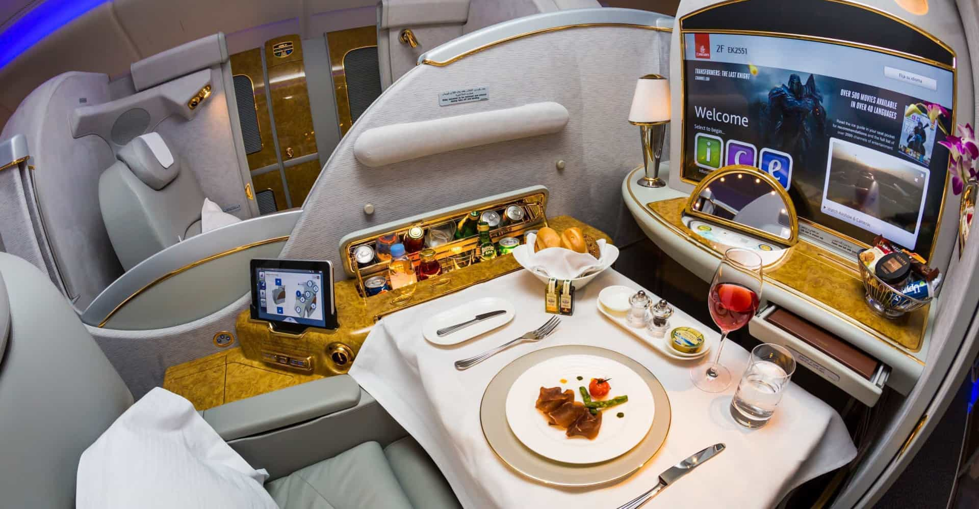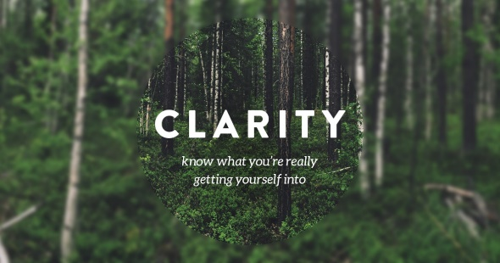She was phoning from Australia, but I was amazed at the clarity of her voice.  
He conveys information with great clarity.  
He had only visited the village once, but remembered it with surprising clarity.  
It will enable us to focus our activities and give us even greater clarity of purpose.

|  |
| --- |
| **class** |

We’re in the same class for chemistry.  
Gary came top of the class in English.  
My class are going to the science museum.  
The class was working on some maths problems.  
There are twenty kids in the class.  
She gets along well with the other children in her class.  
I missed Bible class last week.  
We always travel first class.

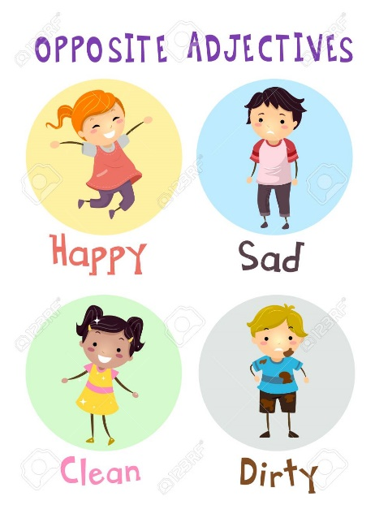

|  |
| --- |
| **classmate** |

Sevgi is taller than most of her classmates.

|  |
| --- |
| **clean** |

The house was clean and tidy.  
The town council is responsible for keeping the streets clean.  
I'm going to clean the windows this morning.  
You should always clean your teeth after meals.

|  |
| --- |
| **clear** |

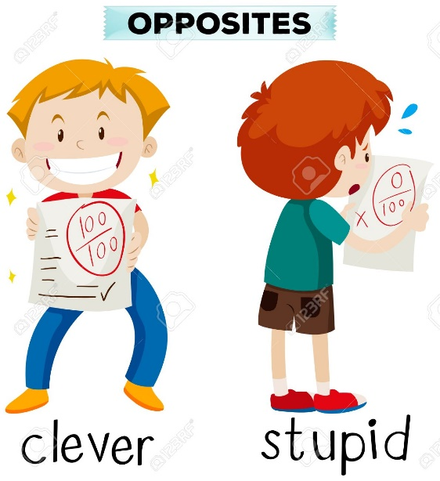It's written in clear, comprehensible English.  
It became clear that he wasn't developing like all the other little boys.  
Her ideas were clear and logically presented.  
He isn't at all clear about what he wants to do with his life.  
The water in the lake is so clear that you can see the bottom.  
It took several hours to clear the road after the accident.  
I'll make the coffee if you'll clear the table.

|  |
| --- |
| **clever: genius: smart** |

Fiona is very clever at physics.  
Charlie has a clever idea/plan for getting us out of our present difficulties.

|  |
| --- |
| **cliché** |

My wedding day - and I know it's a cliché - was just the happiest day of my life.  
He seemed to believe that old cliché about a woman’s place being in the home.  
The term 'information revolution' is a popular cliché.

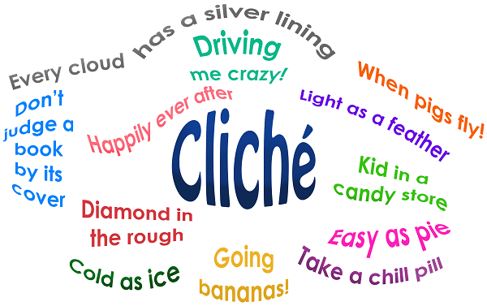

|  |
| --- |
| **cliff** |

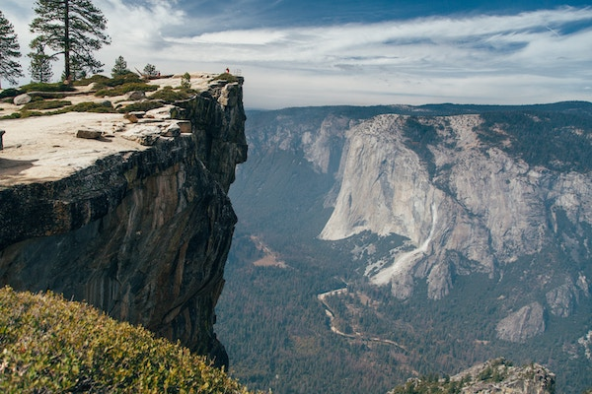Keep away from the edge of the cliff - you might fall.  
They built a house at the foot of a cliff.  
Harold jumped out of the car just before it went over the cliff.  
The cliffs were steep and dangerous.

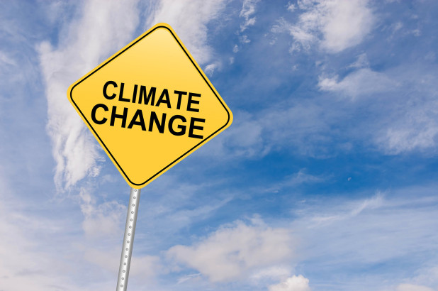

|  |
| --- |
| **climate** |

The Mediterranean climate is good for growing citrus fruits and grapes.  
When we retire, we're going to move to a warmer climate.  
The organizational climate here is pleasant and non-threatening.  
I don't think we should expand our business in the current economic climate.

|  |
| --- |
| **clock** |

I think the kitchen clock is fast/slow (= is showing a later/earlier time than it should).  
The clock began to strike twelve.  
The clock was striking ten as we went into the church.



|  |
| --- |
| **clockwise** |

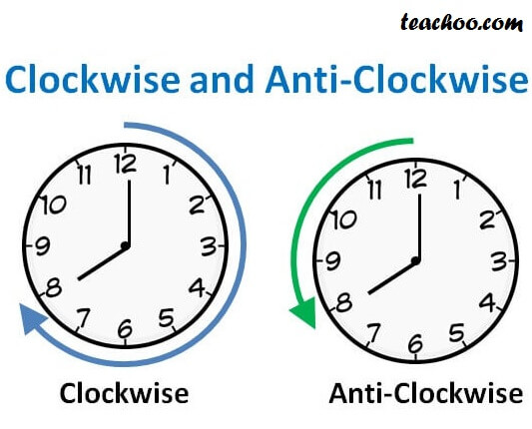The stages commence at the top and move in clockwise direction.

|  |
| --- |
| **cloud** |

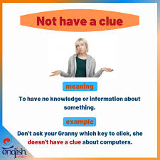The sky was a perfect blue - not a cloud in sight.  
The sun disappeared behind heavy clouds.  
**Every cloud has a silver lining. (Her işte bir hayır vardır)**

|  |
| --- |
| **clue** |

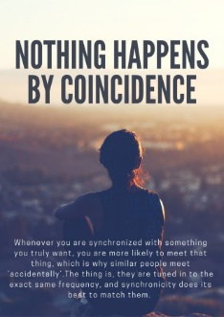**a sign or some information that helps you to find the answer to a problem, question, or mystery:**  
Police are still looking for clues in their search for the missing girl.  
I'm never going to guess the answer if you don't give me a clue.

|  |
| --- |
| **cock :  rooster** |

*rooster an adult male chicken:*

The cock started to crow.

|  |
| --- |
| **coincidence** |

‘I’m going to Appleby tomorrow.’ ‘What a coincidence! I’m going there too.’  
It was sheer/pure coincidence that we were staying in the same hotel.  
It was a remarkable coincidence that two people with the same name were staying at the hotel.  
Just by coincidence, I met my old schoolmate again 50 years later.

|  |
| --- |
| **coke** |



|  |
| --- |
| **cold** |

I've got a cold.  
She caught a cold at school.  
My feet are so cold.  
It's freezing cold today.  
You'll feel cold if you don't wear a coat.

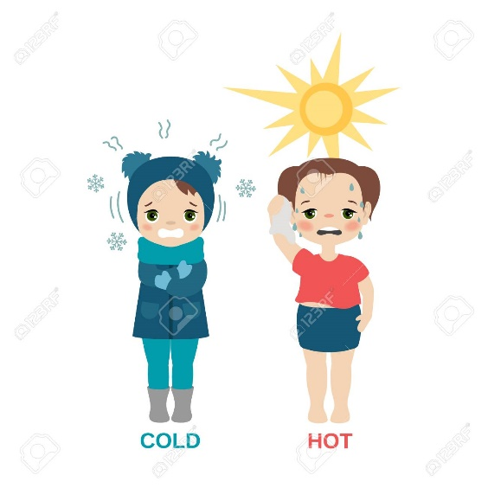

|  |
| --- |
| **collaborate** |

The two nations are collaborating on several satellite projects.  
Researchers are collaborating to develop the vaccine.  
A German company collaborated with a Swiss firm to develop the product.  
In everyday English, people usually say they work together on something rather than collaborate on something:  
They are working together on some new songs.



|  |
| --- |
| **collaboration** |

The two playwrights worked in close collaboration (with each other) on the script.  
The new airport is a collaboration between two of the best architects in the country.  
The mission is being conducted in collaboration with the European space agency.  
Universities and companies are working together in a spirit of collaboration to develop new solutions.

|  |
| --- |
| **collapse** |

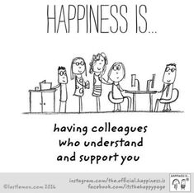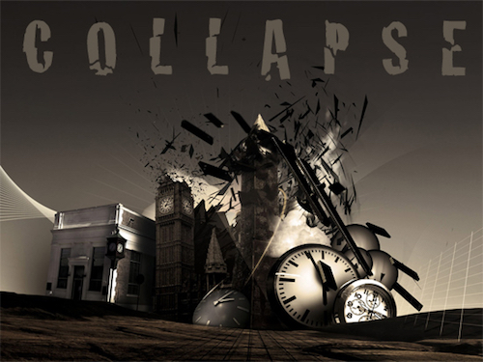Thousands of buildings collapsed in the earthquake.  
The chair collapsed under her weight.  
figurative He thought his whole world had collapsed when his wife died.  
Lots of people lost their jobs when the property market collapsed.  
Talks between management and unions have collapsed.  
He collapsed with a heart attack while he was dancing.

|  |
| --- |
| **colleague /kolig/** |

I don't know anything about this, but I'm sure my colleague here can help you.  
We're having a small drinks party for one of our colleagues who's leaving next week.

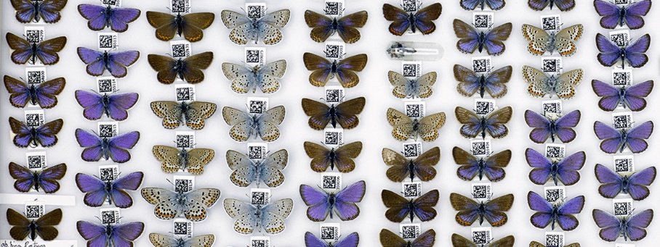

|  |
| --- |
| **collect** |

She collects dolls.  
So when did you start collecting antique glass?

|  |
| --- |
| **collection** |

There's an Egyptian art collection on display at the museum at the moment.  
Rosie has a massive collection of furry toys.  
The curator guided us round the gallery, pointing out the most famous paintings in the collection.  
Her latest fashion collection features shimmering iridescent materials.  
Rachel bought yet another pair of shoes to add to her collection.

|  |
| --- |
| **collide** |

***(especially of moving objects) to hit something violently:***The two vans collided at the crossroads.  
It was predicted that a comet would collide with one of the planets.  
The two cars collided with an ear-splitting crash.

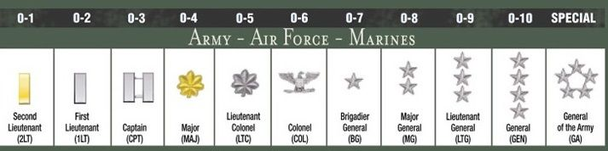***to clash; conflict:***  
Their views on the matter collided.  
For Prisoners in the West, the Virus and the Wildfires Are Colliding Threats.

|  |
| --- |
| **colonel** |

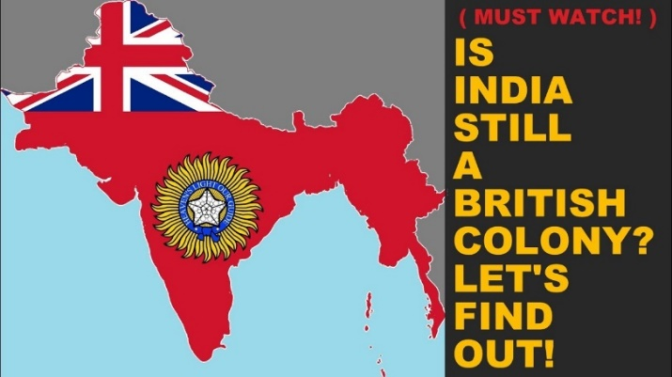Colonel is the military rank between lieutenant-colonel and brigadier.  
At the time, units were still known by their colonels' names.

**colony**

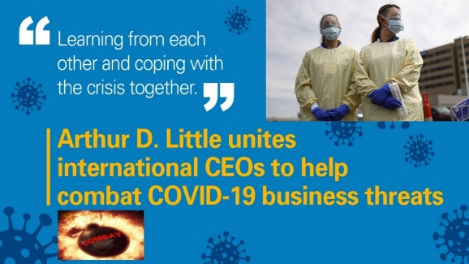Australia and New Zealand are former British colonies.  
India was a British colony.

|  |
| --- |
| **color-blind** |

He's colour-blind and can't distinguish the difference between red and green easily.

|  |
| --- |
| **combat** |

No one knew how many troops had died in combat.  
The government is spending millions of dollars in its attempt to combat drug abuse.  
We must try to combat poverty and illiteracy.  
A conference will be held on how to combat the pollution of the oceans.

|  |
| --- |
| **combine** |

***to (cause to) exist together, or join together to make a single thing or group:***  
None of us has much money so let's combine what we've got.  
The two countries combined against their common enemy.  
Diets are most effective when combined with exercise.

***to do two activities at the same time:***  
She manages to successfully combine family life and/with a career.

|  |
| --- |
| **come forward** |

***to offer help to someone, or offer to do something***  
So far, only one candidate has come forward.  
The police appealed for witnesses to come forward with information.  
No witnesses to the accident have come forward yet, despite the police appeal.  
Nobody has yet come forward with any information relating to the girl's death.

|  |
| --- |
| **comedy** |

His latest movie is described as a "romantic comedy".  
A lot of Shakespeare’s plays are comedies.

|  |
| --- |
| **comet** |

Astronomers had accidentally caught a comet in the act of turning into an asteroid.  
Viewed from space, the normal progress of the survey ship was like the passage of a comet.

|  |
| --- |
| **comic** |

She is one of the most gifted comic actresses on television.  
The speech had several comic touches.

(also mainly US **comic book**)

*a magazine or book that contains a set of stories told in pictures with a small amount of writing*

|  |
| --- |
| **comical** |

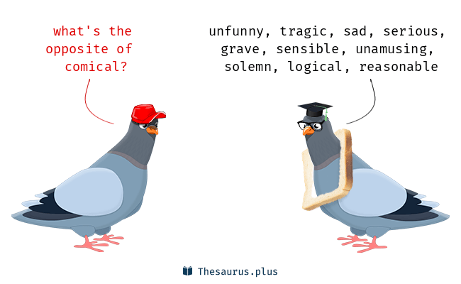Tell me the truth – do I look comical (= strange or foolish) in this hat?  
He looked so comical in that hat.

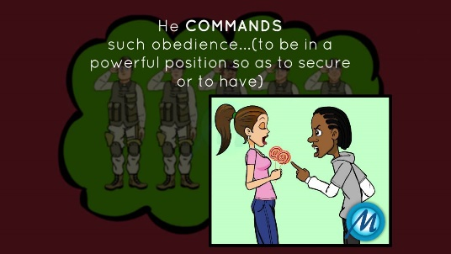

|  |
| --- |
| **command** |

He hated being in the army because he had to obey commands.  
The command was given to ceasefire.  
The officer commanded his men to shoot.  
The police commanded the driver to stop the car.

|  |
| --- |
| **commander** |

The soldiers fired as soon as their commander gave the order.  
The commander paid tribute to the courage of his troops.  
The commander has asked us to send reinforcements.  
The troops will go into action as soon as their commander gives the word.

|  |
| --- |
| **comment** |

I don't want any comments on/about my new haircut, thank you!  
My mum always comments on what I'm wearing.  
He commented that the two essays were rather similar.  
Do you have any comments on that, David?



|  |
| --- |
| **commercial** |

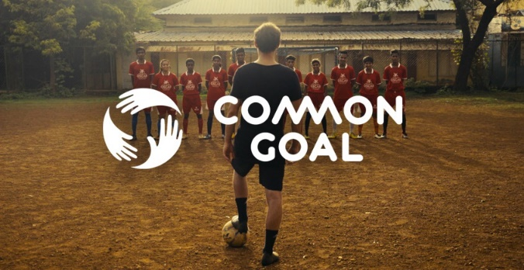Our top priorities must be profit and commercial growth.  
Many commercial companies are having financial difficulties.  
The increased number of tourists has resulted in further commercial development.  
The commercial future of the company looks very promising.

|  |
| --- |
| **common** |

Bad dreams are fairly common among children.  
These problems are common to all societies.  
Jones is a very common name in Great Britain.  
Foxes are common in the area.  
This disease is four times more common in boys than in girls.  
One common cause of homelessness is separation or divorce.

|  |
| --- |
| **communicate** |

We communicated mostly by e-mail.  
A teacher must be able to communicate effectively to students.  
Parents sometimes find it difficult to communicate with their teenage children.  
Unable to speak a word of the language, he communicated with (= using) his hands.

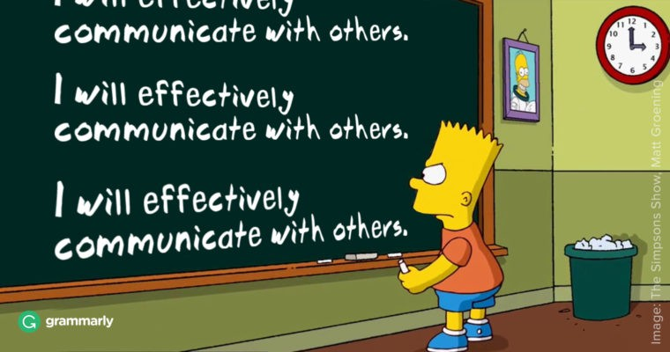

|  |
| --- |
| **compassion** |

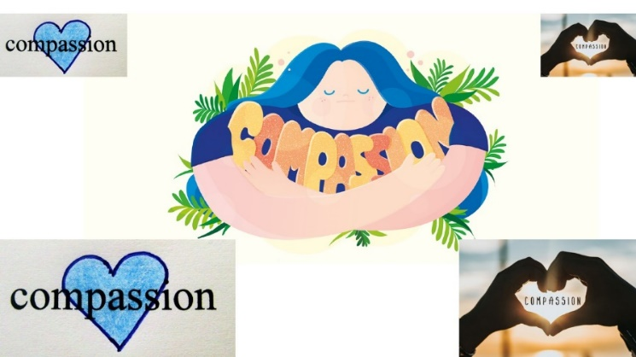I was hoping she might show a little compassion.  
The report criticizes his arrogance, lack of compassion, and intimidating manner.  
Russell's father had no compassion for his son's physical disabilities.

|  |
| --- |
| **compel** |

The law will compel employers to provide health insurance.  
She felt compelled to resign because of the scandal.  
As a schoolboy, he was compelled to wear shorts even in winter.

|  |
| --- |
| **competetive** |

***determined or trying very hard to be more successful than other people or businesses |  
rekabetçi***  
Some US industries are not as competitive as they have been in the past.  
Competitive sports encourage children to work together as a team.  
The hotel offers a high standard of service at competitive rates.  
***(products or prices that are competitive are cheaper than others but still of good quality)***



|  |
| --- |
| **complain:** |

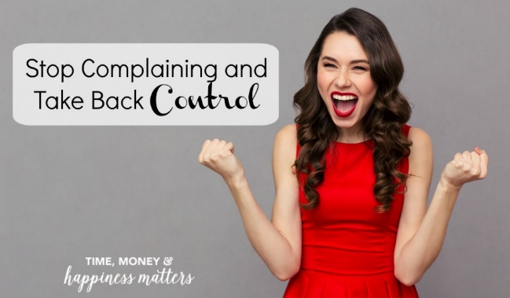Lots of people have complained about the noise.  
You're always complaining!  
He complained that his boss was useless and he had too much work.  
They are always complaining about their neighbor, whose dog frightens their kids.

|  |
| --- |
| **complementary** |

***the state of working usefully together: tamamlayıcı  
complementary things go well together, although they are usually different:***  
London's time zone position offers a natural complementarity with New York and Tokyo for trading of securities.  
The computer and the human mind have different but complementary abilities.  
Bain and McCaskill have complementary skills - she is creative while he is highly organized.

|  |
| --- |
| **complete: finish** |

All she needed to complete her happiness was a baby.  
Have you completed your application form yet?  
He's just completed filming his 17th feature film.

I have complete confidence in her. She'll be perfect for the job.  
The evening was a complete disaster.

|  |
| --- |
| **completely: totally** |

Have you completely lost your mind?  
I agree with you completely.  
She's completely mad.  
He'd completely changed - I didn't recognize him.

|  |
| --- |
| **comprehend** |

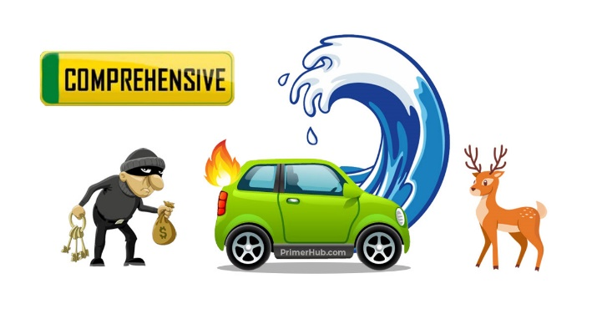I fail to comprehend their attitude.  
He doesn't seem to comprehend the scale of the problem  
I'll never comprehend why she did what she did.  
I don't think he fully comprehends that she won't be here to help him.

|  |
| --- |
| **comprehensive** |

***complete and including everything that is necessary:***  
We offer you a comprehensive training in all aspects of the business.  
Is this list comprehensive or are there some names missing?  
He has written a fully comprehensive guide to Rome.

***Comprehensive insurance gives financial protection against most risks, for example including damage to a driver's own vehicle as well as to other vehicles:***  
It is a common misconception that car hire insurance is comprehensive.

|  |
| --- |
| **compromise** |

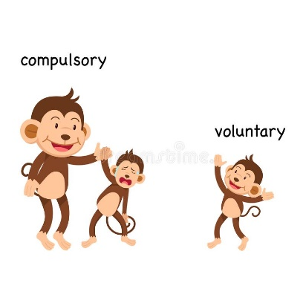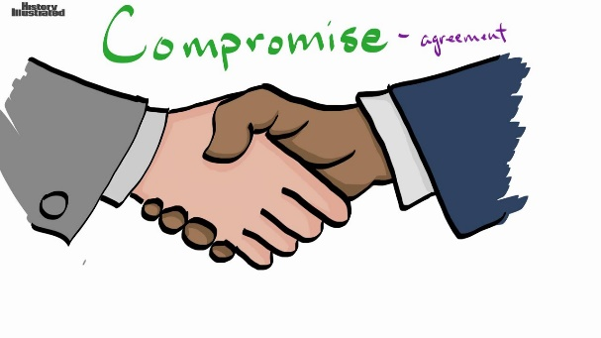***an agreement in an argument in which the people involved reduce their demands or change their opinion in order to agree:***  
It is hoped that a compromise will be reached in today's talks.  
In a compromise between management and unions, a four percent pay rise was agreed in return for an increase in productivity.  
The government has said that there will be no compromise with terrorists.

***to accept that you will reduce your demands or change your opinion in order to reach an agreement with someone:***  
Party unity is threatened when members will not compromise.  
Well, you want $400 and I say $300, so let's compromise at/on $350.

|  |
| --- |
| **compulsory** |

Car insurance is compulsory.  
Maths and English are compulsory for all students.  
Compulsory education was introduced in 1870.  
Wearing a seat belt is compulsory.

|  |
| --- |
| **computer** |

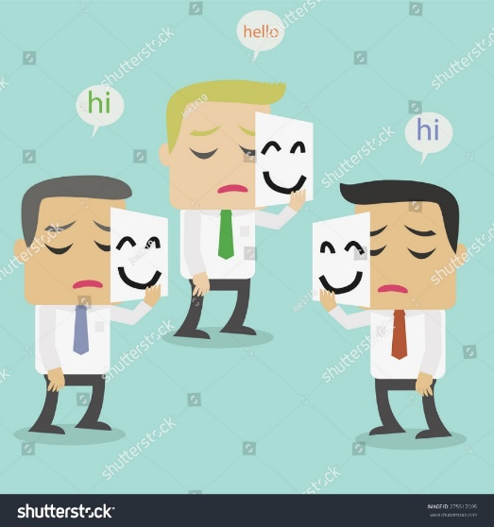I need some advice on which computer to buy.  
When you buy a new computer, you usually get software included at no extra cost .  
Modern computers can hold huge amounts of information.

|  |
| --- |
| **conceal** |

***to prevent something from being seen or known about:***  
The listening device was concealed in a pen.  
I tried to conceal my surprise when she told me about her age.  
Is there something you're concealing from me?  
The path was concealed by long grass.  
She tried to conceal the fact that she was pregnant.

|  |
| --- |
| **conclusion** |

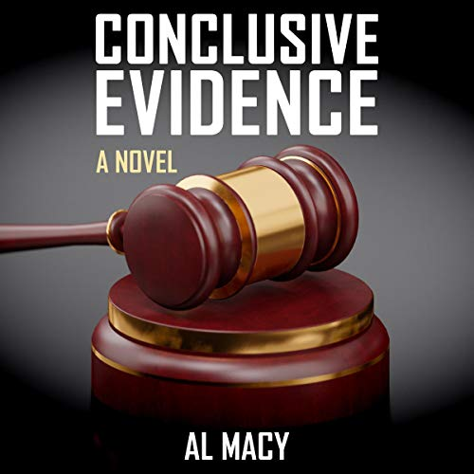The conclusion of your essay is good, but the final sentence is too long and complicated.  
I soon came to the conclusion that she was lying.  
It is still too early to reach a conclusion on this point.  
At the conclusion of the meeting, little progress had been made.  
**In conclusion**, I would like to thank our guest speaker.

|  |
| --- |
| **conclusive** |

***proving that something is true, or ending any doubt:***  
They had conclusive evidence/proof of her guilt.  
The investigation failed to provide any conclusive evidence.  
We still have no conclusive proof that Walters was at the scene of the crime.

|  |
| --- |
| **condemn** |

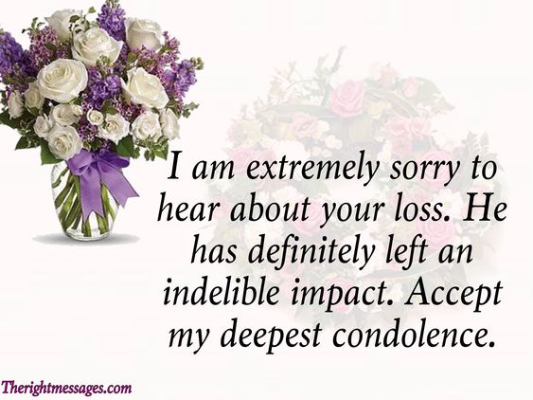Politicians were quick to condemn the bombing.  
She knew that society would condemn her for leaving her children.  
The terrorist action has been condemned as an act of barbarism and cowardice.  
The film was condemned for its sexism.  
She was the only politician to condemn the proposed law on moral grounds.

|  |
| --- |
| **condolence** |

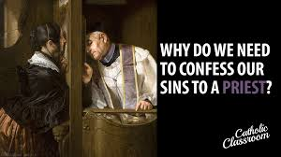Derek debated whether to telephone Charlotte Ladram and offer his condolences, but, in the end, he decided not to.  
I was able to talk with visitors offering condolences, to endure two memorial ceremonies without falling apart.  
May I take this opportunity to offer my condolences.  
After the service, the other mourners came to offer their condolences.

|  |
| --- |
| **confess : admit** |

He has confessed to the murder.  
She confessed to her husband that she had sold her wedding ring.

|  |
| --- |
| **confession** |

I have a confession to make - I've lost that book you lent me.  
He made a full confession to the police.  
After being questioned by the police for two days, Johnson signed a confession.  
The two men allege that the police forced them to make false confessions.



|  |
| --- |
| **confidence** |

He has the confidence to walk into a room of strangers and immediately start a conversation.  
She's completely lacking in confidence.  
I have every/complete confidence in her. She'll be perfect for the job.

|  |
| --- |
| **confident : sure** |

Be a bit more confident in yourself!  
They don't sound confident about the future of the industry.



|  |
| --- |
| **confirm** |

New evidence has confirmed the first witness’s story.  
To confirm my diagnosis I need to do some tests.  
It was confirmed that the bone was broken.  
Could you confirm the dates we discussed?  
Six people have confirmed that they will be attending and ten haven't replied yet.  
Flights should be confirmed 48 hours before departure.  
I've accepted the job over the phone, but I haven't confirmed in writing yet.

|  |
| --- |
| **confirmation** |

There has still been no official confirmation of the report.  
We've only received five confirmation for the conference so far.  
We will send you a written confirmation of our offer shortly.  
If I was in any doubt about who had eaten the cake, Jack's chocolate-smeared face was enough confirmation!  
We are still awaiting confirmation of the exact number of casualties.

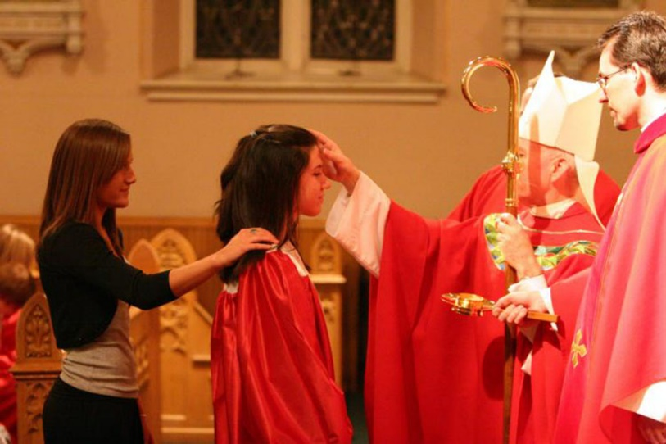

***a ceremony in which someone is confirmed into the Christian Church***

|  |
| --- |
| **conflict - fikir ayrılığı** |

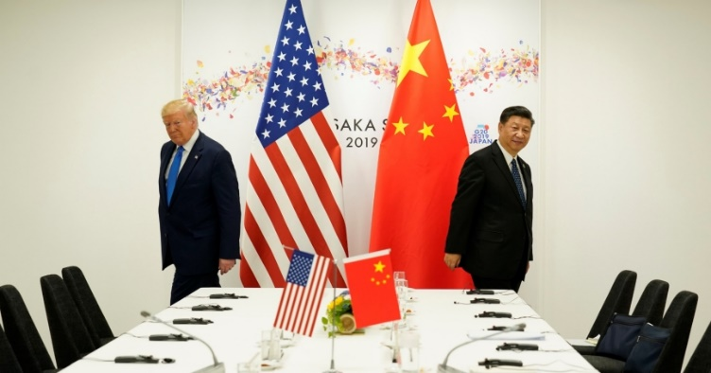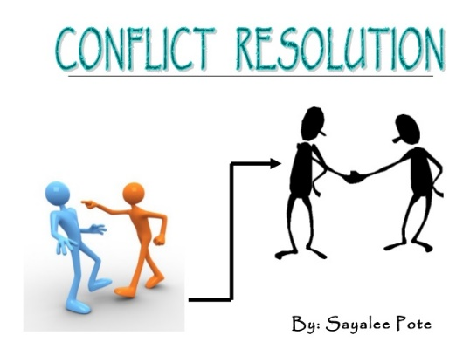There was a lot of conflict between him and his father.  
It was an unpopular policy and caused a number of conflicts within the party.  
Some of her actions have brought her into conflict with her managers.  
You may need a lawyer to resolve a serious conflict between neighbors.

|  |
| --- |
| **confront** |

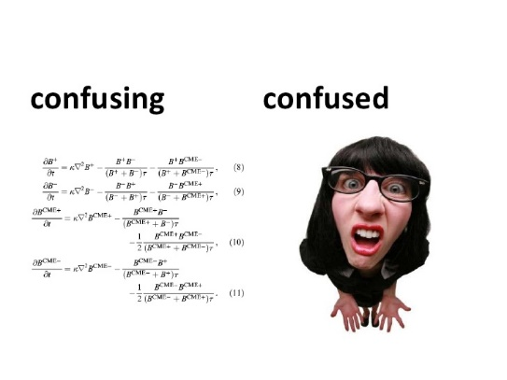As she left the court, she was confronted by angry crowds who tried to block her way.  
It's an issue we'll have to confront at some point, no matter how unpleasant it is.  
I thought I would stay calm, but when I was confronted with/by the TV camera, I got very nervous.  
We were confronted with a lot of problems when we tried to buy a house in Germany.

|  |
| --- |
| **confused** |

I am a little bit confused.  
This letters are confusing. Could you help me with them please?

|  |
| --- |
| **confusing** |

We have two people called Paul James working here, so it's a bit confusing!  
The instructions are really confusing. Could you help me with them, please?

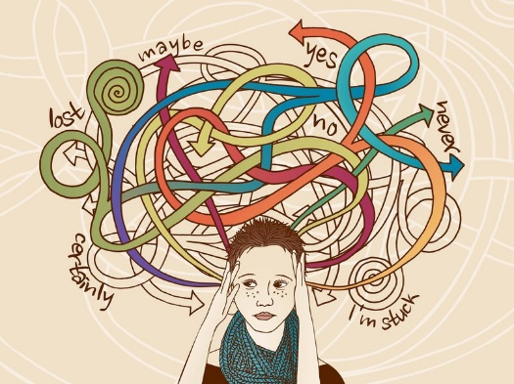

|  |
| --- |
| **confusion** |

There seems to be some confusion over who is actually giving the talk.  
To avoid confusion, the twins never wore the same clothes.  
There is a confusion in the public mind between psychology and psychiatry.

|  |
| --- |
| **Congratulations!** |

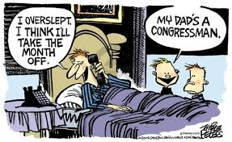*- KINGARCILEYŞINS -*  
“I passed my driving test.” “Congratulations!”  
Give him my congratulations when you see him.

|  |
| --- |
| **congressman** |

***a man who belongs to a congress, especially a member of the US House of Representatives***

|  |
| --- |
| **conjugate /koncugeyt/** |

***if a verb conjugates, it has different forms to show different tenses etc.***  
The verb ‘to go’ conjugates irregularly.  
We have to conjugate these verbs in Latin.

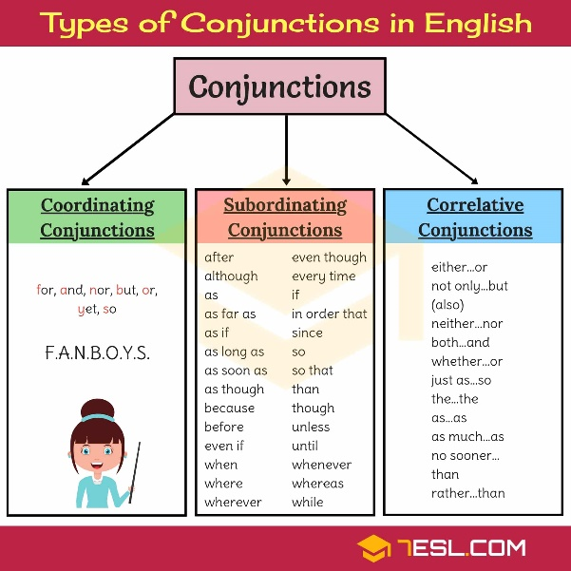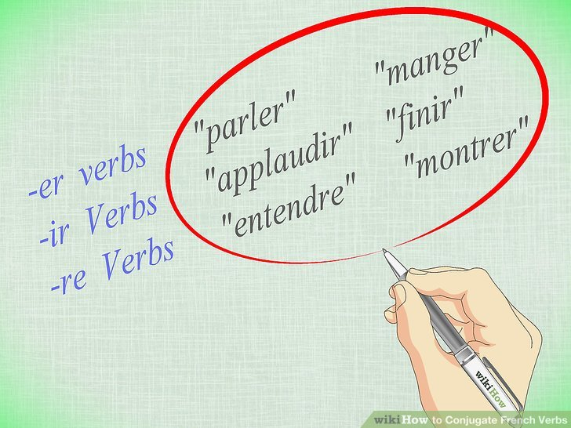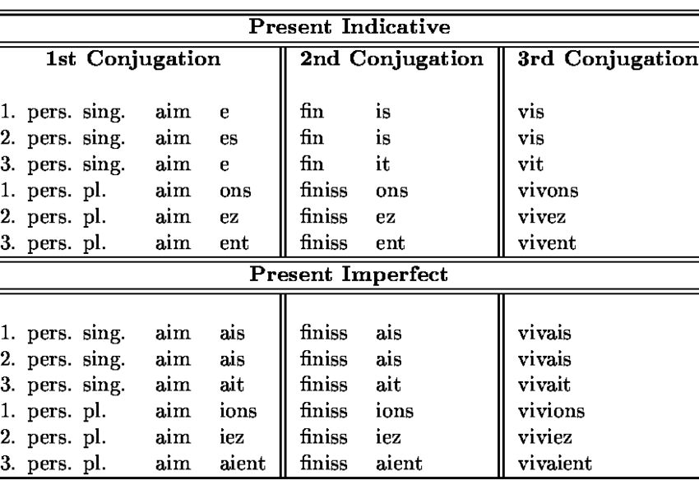

|  |
| --- |
| **conjunction /kıncangşın/** |

**a word such as 'and', 'but', 'while', or 'although' that connects words, phrases, and clauses in a sentence**  
The conjunction "although" joins the two clauses in the sentence "He left, although I begged him not to."

When you write a series of nouns or adjectives, such as 'purple, green and blue', you use conjunction before the last one, instead of a comma.

***the situation in which events or conditions combine or happen together:***  
Unfortunate conjunction of circumstances led to his downfall.  
There is a team of writers working in conjunction (with each other) on the book.

|  |
| --- |
| **connect** |

I didn’t connect the two events in my mind.  
Click here to connect to the Internet.  
Please hold the line. I’m trying to connect you.  
The two lakes are connected by a narrow canal.  
The Golden Gate Bridge connects San Francisco with Marin County.

|  |
| --- |
| **connection** |

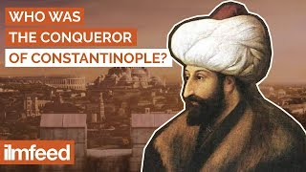There is a connection between pollution and the death of trees.  
Williams apparently has no connection to the case.  
Police have so far failed to establish a connection between the two murders.  
Students often see little connection between school and the rest of their lives.  
A lot of social problems have a direct connection to alcohol or drug use.  
It's easy to see a connection between stress and illness.  
Scientists have attempted to establish a connection between these two theories.  
There is nothing to suggest a connection between the hospital food and the illness.

|  |
| --- |
| **conquer** |

The capital of the Eastern Roman Empire, Constantinople was **conquered** by the Ottoman Army, under the command Ottoman Sultan Mehmed II on 29th May 1453.

|  |
| --- |
| **conqueror** |

After the Constantinople **conquest**, 21 years old Ottoman Sultan II. Mehmed also took the title “The **Conqueror**” added to his name.

|  |
| --- |
| **conquest** |

With this **conquest** Ottomans became an Empire and one of the most powerful empires, The Eastern Roman Empire fell and lasted.

|  |
| --- |
| **consensus** |

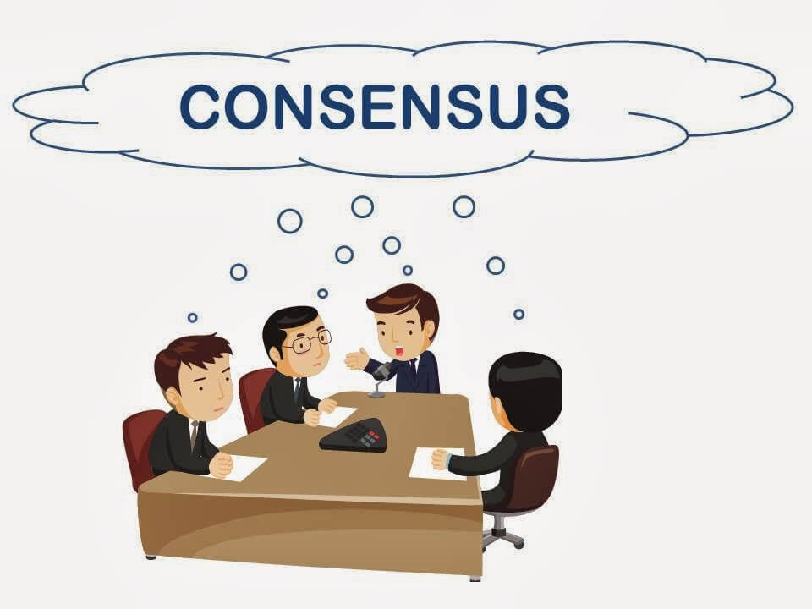The general consensus in the office is that he can't do his job.  
Could we reach a consensus on this matter? Let's take a vote.

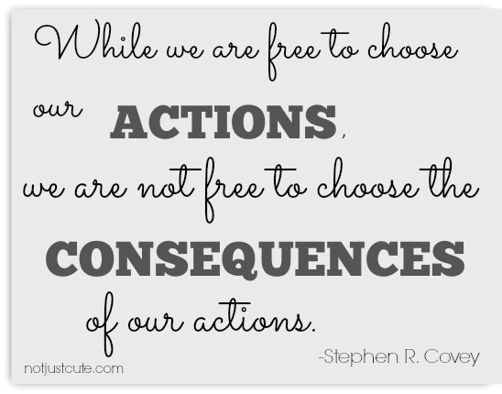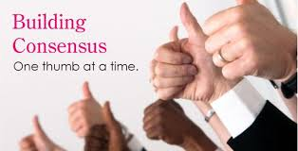We were unable to reach a consensus about membership fees.  
There is little consensus about the issue of smacking children.  
We managed to get a consensus about not smoking in the office.

|  |
| --- |
| **consequence** |

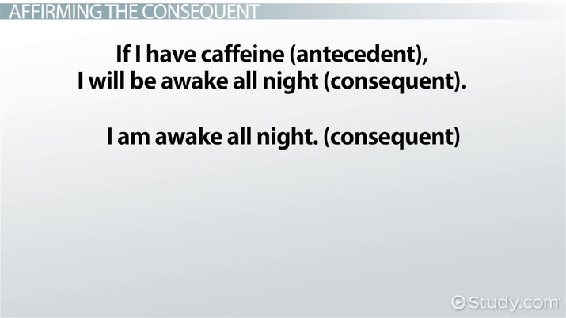Many believe that poverty is a direct consequence of overpopulation.  
Low energy may be a consequence of sleeping badly.  
Taking financial risks can have serious consequences.  
I’m prepared to accept the consequences of my decision.  
He broke the law, and he will have to face the consequences.  
She jumped into the river without considering the consequences.  
The spread of information has been a direct consequence of the Internet.

|  |
| --- |
| **consequent** |

Our use of harmful chemicals and the consequent damage to the environment is a very serious matter.  
The drought and consequent famine struck most of the country.  
Researchers may be unaware of their uncritical acceptance of categories and consequent results.

|  |
| --- |
| **consequently** |

I spent most of my money in the first week and consequently had very little to eat by the end of the holiday.  
All the shops were closed, and consequently, we couldn't buy any food.  
His explanation was full of technical jargon. Consequently, nobody understood it at all!

|  |
| --- |
| **consist of** |

My family consists of four people.  
The building consists of four floors.  
There is a large art collection, consisting of over 300 paintings.  
The apartment consisted of three rooms.  
The crowd consisted mostly of college kids and office workers.  
Her responsibilities consist of answering the phone and greeting visitors.

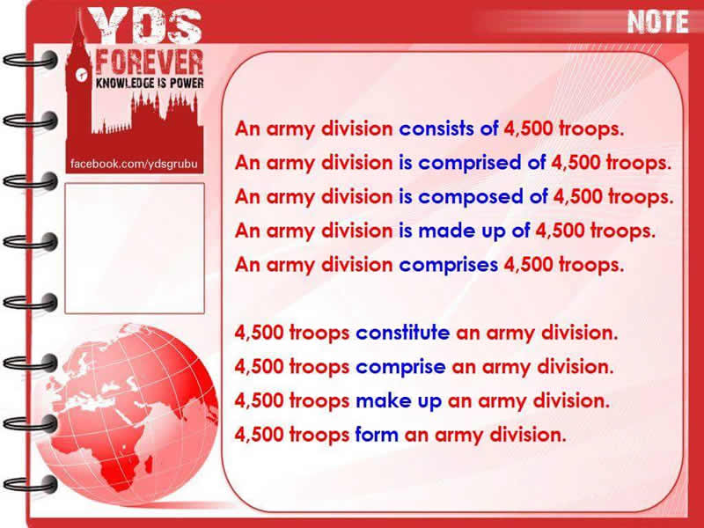

|  |
| --- |
| **consolidate** |

**to strengthen the position of power or success that you have, so that it becomes more effective or continues for longer**  
The company has consolidated its position as the country’s leading gas supplier.  
She hoped that marriage would consolidate their relationship.

**to combine things in order to make them more effective or easier to deal with**  
We consolidate information from a wide range of sources.

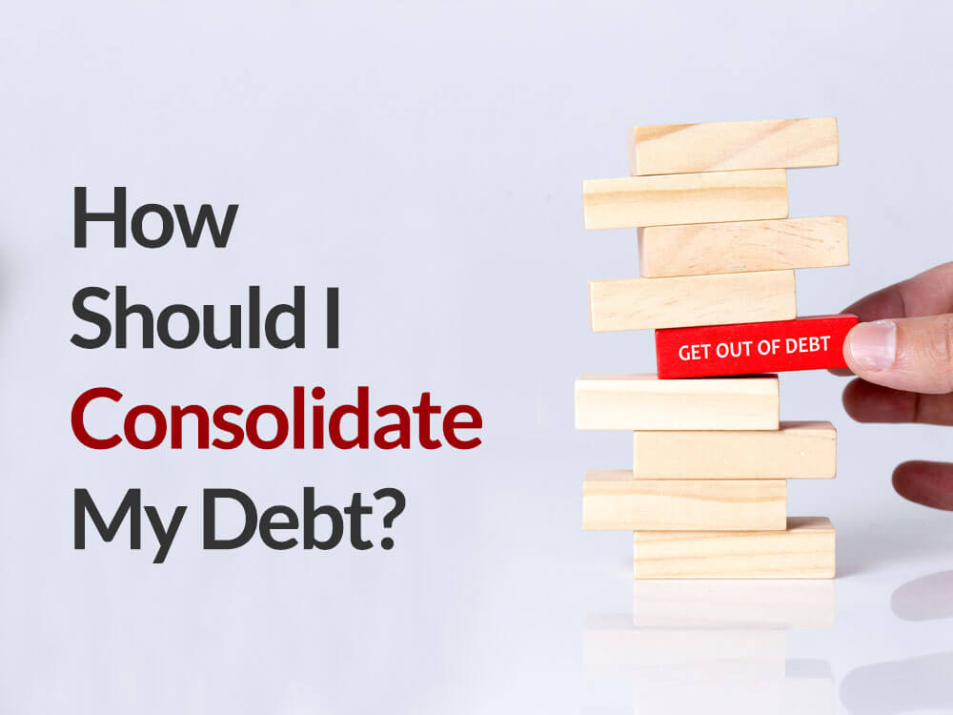

|  |
| --- |
| **conspiracy** |

***the activity of secretly planning with other people to do something bad or illegal:*komplo**

The three men are accused of conspiracy.  
She has been charged with conspiracy to murder.  
I think there was a conspiracy to keep me off the committee.  
There were many conspiracy theories (=beliefs that something is the result of a conspiracy) surrounding Princess Diana’s death.  
Moon landing conspiracies continue decades after Apollo 11.

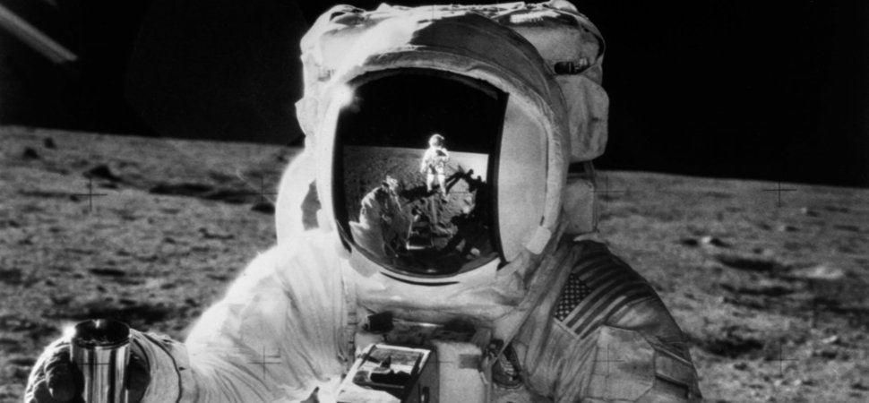

|  |
| --- |
| **constitution** |

The right to speak freely is written into the Constitution of the United States.  
Britain has no written constitution.  
Britain's unwritten constitution allows for flexibility when circumstances change.  
The American constitution was drafted in 1787.

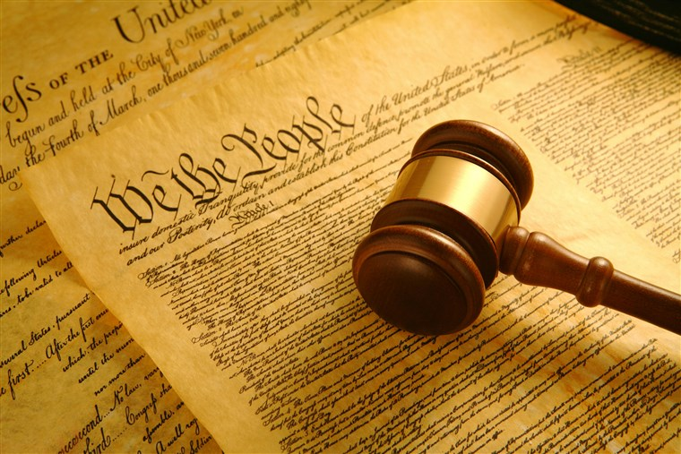

|  |
| --- |
| **consult** |

If the symptoms get worse, consult your doctor.  
I'm not quite sure how to get there - I'd better consult a map.  
He didn't consult me about this.  
This afternoon the president was consulting with his advisers.  
If any of these symptoms occur while you are taking the medicine, consult your doctor immediately.  
If the pain persists, consult a doctor.

|  |
| --- |
| **consultation** |

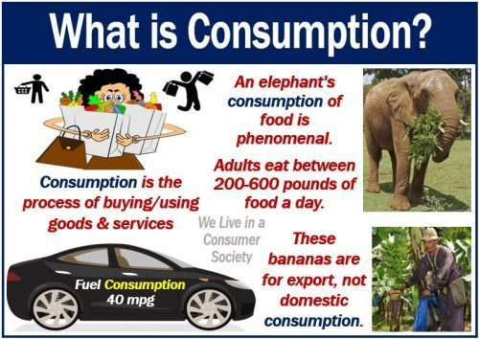After consultations with our accountants, we've decided how to cut costs within the company.  
She spent hours in consultation with her lawyers.  
We hope to work in consultation with Congress on how the law should be interpreted.

|  |
| --- |
| **consume** |

Only 27% of the paper we consume is recycled.  
A smaller vehicle will consume less fuel.  
The UK and France consume more gas than Italy, mainly because of their colder climates.  
We consumed vast quantities of food and drink that night.

|  |
| --- |
| **consumption** |

We need to cut down on our fuel consumption by having fewer cars on the road.  
Consumption of electricity is always higher during the summer months because of air-conditioning.  
The Government wants to reduce tobacco consumption by 40%.  
Other factors can be, such as obesity, high alcohol consumption and lack of exercise.

|  |
| --- |
| **contagious** |

***a disease that is contagious can be passed from person to person by touch***  
The patient is still highly contagious.  
Most eye infections are contagious.  
People with measles are highly contagious.  
Chicken pox is a highly contagious disease.

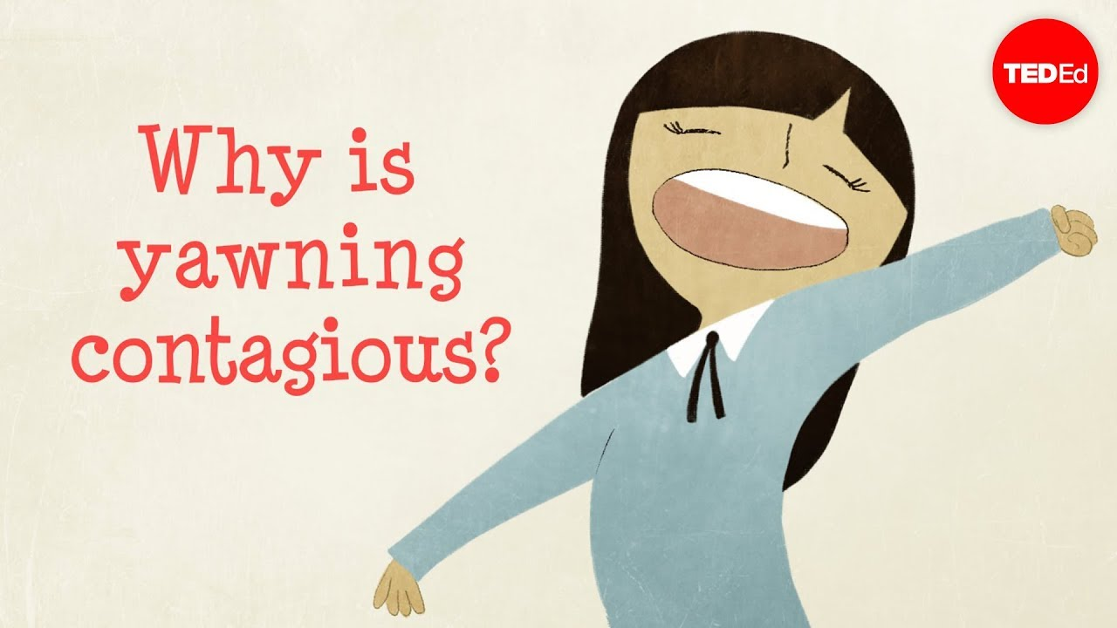

|  |
| --- |
| **content** |

Andy was a good husband, and Nicky was clearly very content.  
We’ll be content with a respectable result in tomorrow’s match.  
He seems fairly content with (his) life.  
They're content to socialize with a very small circle of people.

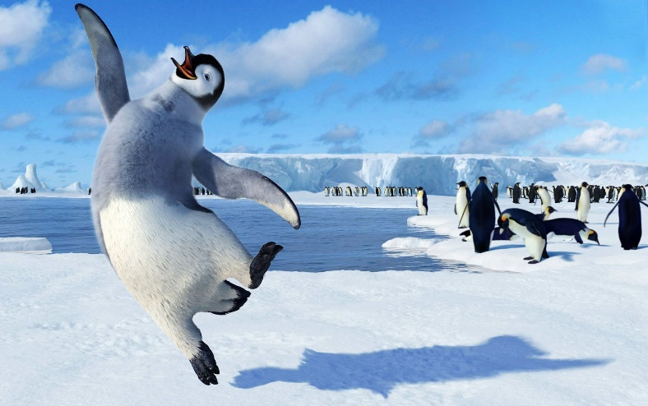

|  |
| --- |
| **contest** |

Stone decided to hold a contest to see who could write the best song.  
I only entered the contest for fun.  
Anyone over 18 years old can enter the contest.  
Twenty-five countries took part in the contest.  
He won a public-speaking contest at his school.



|  |
| --- |
| **contingent on / upon sth** |

***depending on something else in the future in order to happen:***  
The contract is contingent on approval by the Board of Trustees.  
Buying the new house was contingent on selling the old one.  
Our success is contingent upon your support.



|  |
| --- |
| **continue: go on : carry on** |

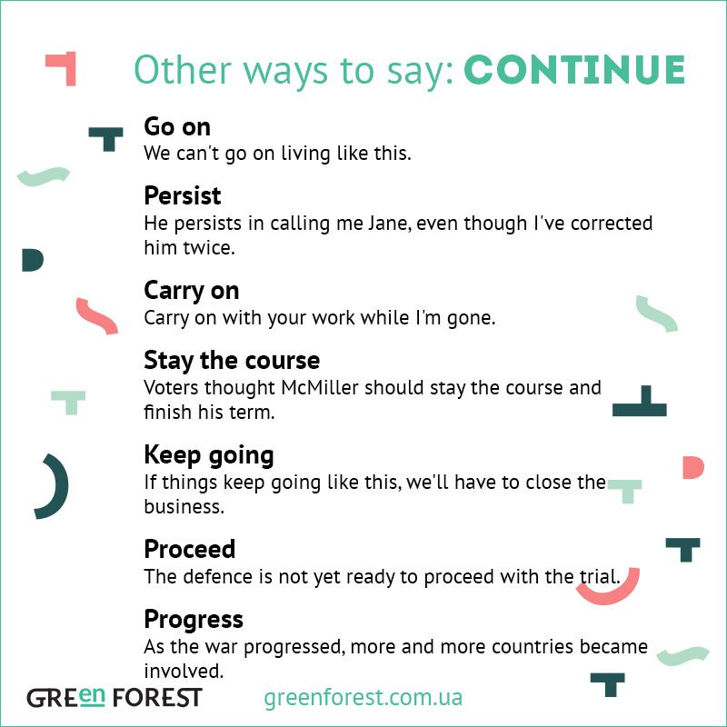Sheila continued to work after she had her baby.  
He will be continuing his education in the US.  
The strike continued for another four weeks.

Rescue teams will continue the search tomorrow.  
He picked up his book and continued reading.  
We need the money to continue our work.  
They continued arguing for a long time.  
Despite all the warnings, many people continue to smoke.

|  |
| --- |
| **contrast** |

While there are similarities in the two cultures, there are also great contrasts.  
There's a marked contrast between his character and hers.  
There's a striking contrast between what he does and what he says he does.  
The birth rate for older women has declined, but, **by contrast**, births to teenage mothers have increased.  
The stock lost 60 cents a share, **in contrast** to last year, when it gained 21 cents.



|  |
| --- |
| **control** |

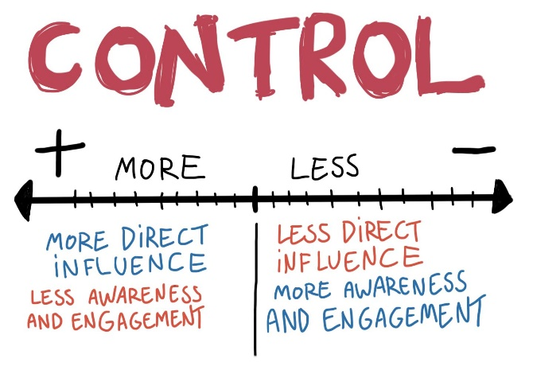You're going to have to learn to control your temper.  
The temperature is controlled by a thermostat.  
The laws controlling drugs are very strict in this country.  
The government is trying to control spending.  
The finance committee controls the school's budget.  
The dictator took control of the country in 1933.

|  |
| --- |
| **controversial** |

***anlaşmazlığa neden olan, ihtiaflı***

I tried to avoid controversial topics such as politics and religion.  
The court’s decision was highly controversial.  
Abortion is a controversial subject.

|  |
| --- |
| **convert** |

*to (cause something or someone to) change in form or character:*  
Could we convert the small bedroom into a second bathroom?  
What's the formula for converting pounds into kilograms?

*to change to a new religion, belief, opinion, etc., or to make someone do this:*  
He converted to (= started believing in) Catholicism when he got married.

|  |
| --- |
| **convey** |

**to express a thought, feeling, or idea so that it is understood by other people:**

His poetry conveys a great sense of religious devotion.  
Please convey our condolences to the family.  
I tried to convey in my speech how grateful we all were for his help.  
You don't want to convey the impression that we're not interested.  
All this information can be conveyed in a simple diagram.  
Ads convey the message that thin is beautiful.

|  |
| --- |
| **convince** |

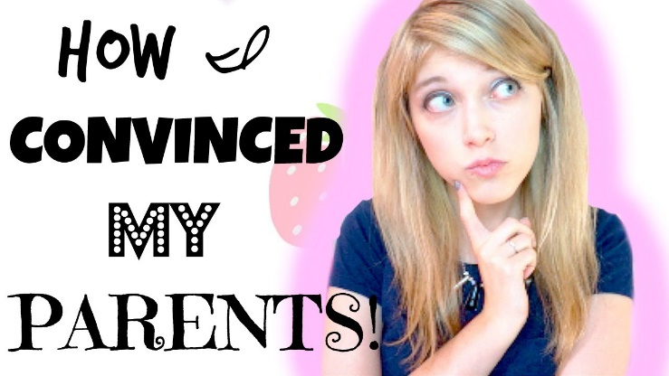***to persuade someone or make someone certain:***  
He managed to convince the jury of his innocence.  
It's useless trying to convince her (that) she doesn't need to lose any weight.  
I hope this will convince you to change your mind.  
We tried to convince my grandfather to live with us.  
I’ve been trying to convince Jean to come with me.

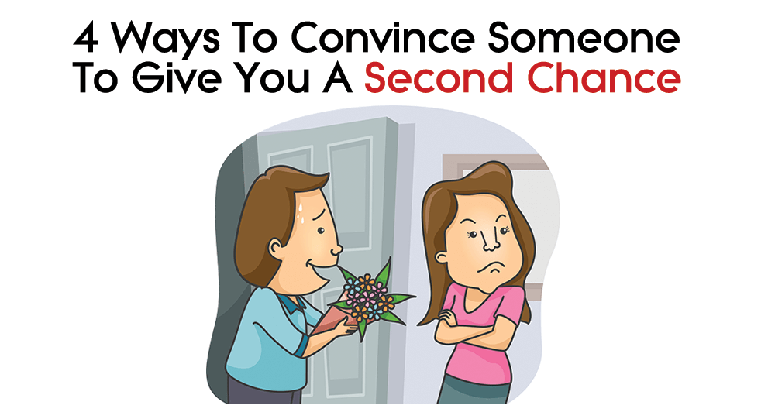

|  |
| --- |
| **convinced** |

My boyfriend says I'd like going on a camping trip, but I'm not convinced.  
I'm convinced (that) she is lying.  
John agreed, but she did not sound very convinced.  
I was convinced that we were doing the right thing.



|  |
| --- |
| **cool** |

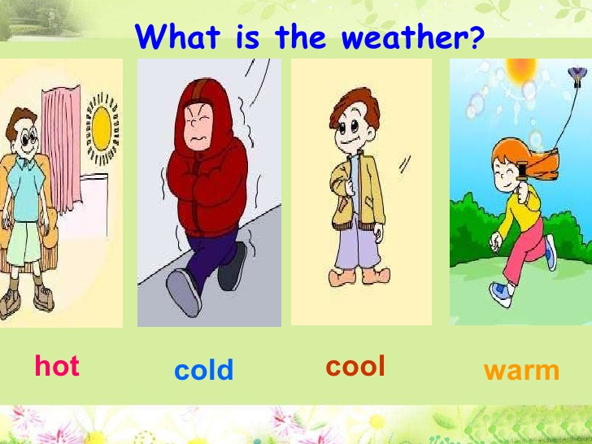She swam out into the cool water.  
The evening air was cool.  
Relax in the sun with a cool drink.

He was very cool when we broke the window, and didn't shout or get mad.  
Stay/Keep cool (= do not become angry or excited).



"So how was the concert?" "It was cool!"  
Our new car is really cool.  
You have such a cool bedroom.

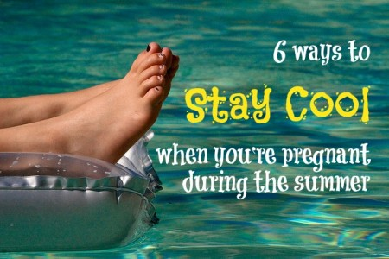

|  |
| --- |
| **cooperate** |

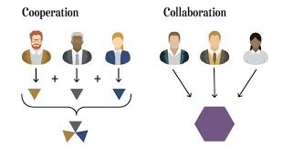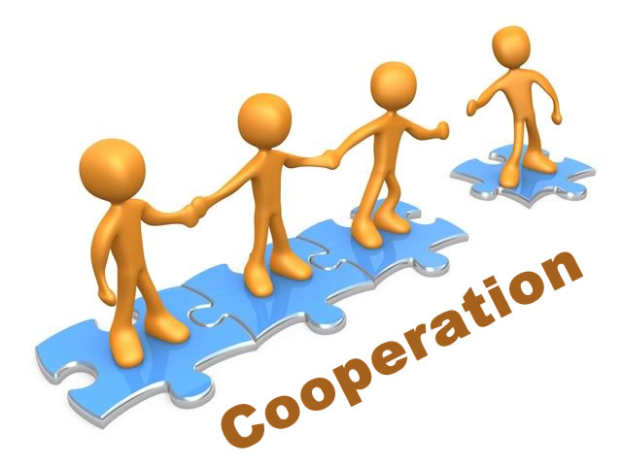***to act or work together for a particular purpose, or to be helpful by doing what someone asks you to do:***  
A two-year-old is likely to refuse to cooperate when you tell her to get dressed.  
The two companies have cooperated in joint ventures for the past several years.  
The Spanish authorities cooperated with the British police in finding the terrorists.

|  |
| --- |
| **cooperation** |

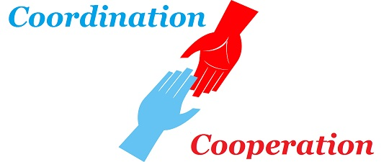This documentary was made with the cooperation of the victims' families.  
There's very little cooperation between the two countries.  
The company produces computers in cooperation with a German firm.

|  |
| --- |
| **coordinate** |

***to make many different things work effectively as a whole:***  
We need someone to coordinate the whole campaign.  
A number of charities are coordinating their efforts to distribute food to the region.

|  |
| --- |
| **coordination** |

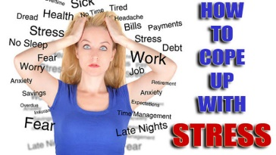***the act of making all the people involved in a plan or activity work together in an organized way:***  
There's absolutely no coordination between the different groups - nobody knows what anyone else is doing.

|  |
| --- |
| **cope with** |

It must be really hard to cope with three young children and a job.  
It's only been a year since he died - how's she coping?  
He had so much pressure on him in his job that eventually he just couldn't cope.

|  |
| --- |
| **coral** |

They spent $ 2 million on environmental measures, he said, and hired biologists to replant coral that would be damaged.  
Fish tucked into crevices peer out, while crabs scavenge over the reef and probe soft corals for food.

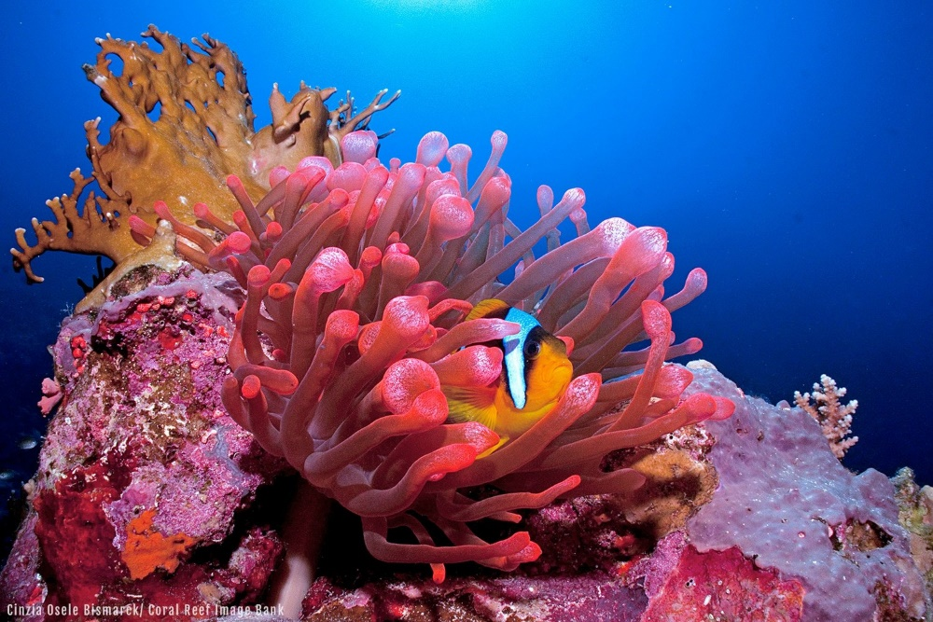

|  |
| --- |
| **corn** |

Do you feed your chickens corn?  
All our chickens are fed on corn.

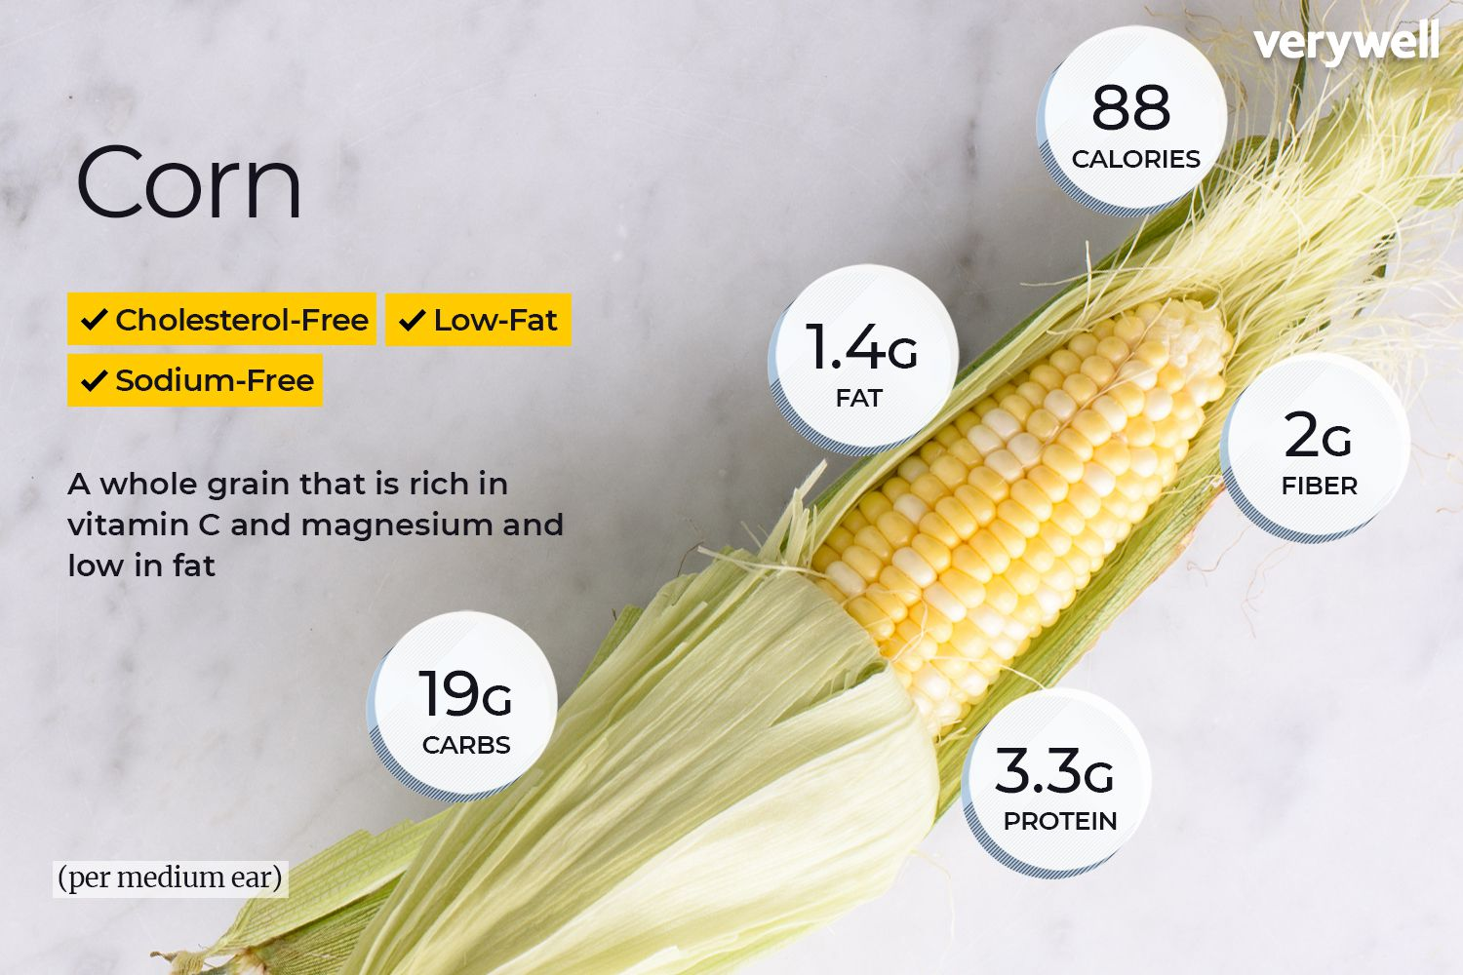

|  |
| --- |
| **corporate** /korpırıt/ |

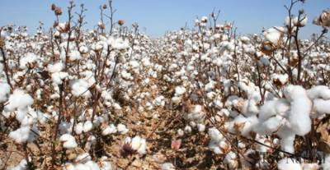We have to change the corporate structure to survive.  
Analysts are expecting share prices to fall in the first quarter of next year because of poor corporate earnings.  
The rating assesses the average risk of payment default of corporates in the country.  
*Organizational memory (OM) (sometimes called institutional or corporate memory) is the accumulated body of data, information, and knowledge created in the course of an individual organization's existence.  
Corporate culture refers to the shared values, attitudes, standards, and beliefs that characterize members of an organization and define its nature. Corporate culture is rooted in an organization's goals, strategies, structure, and approaches to labor, customers, investors, and the greater community.*

|  |
| --- |
| **cotton** |

He shivered with cold in his thin cotton shirt.  
Black slaves used to work on the cotton plantations of the southern United States.

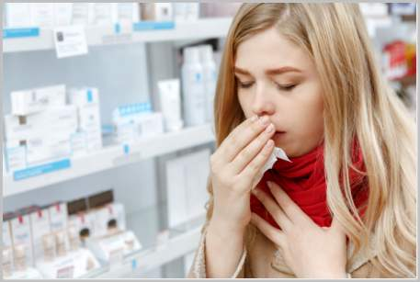 

|  |
| --- |
| **cough /kaf/** |

She was coughing yesterday.  
The smoke made me cough.

|  |
| --- |
| **count** |

I was amazed at the number of plants – I counted 147.  
Sarah can count up to five now.  
The teachers counted the students as they got on to the bus.  
He began counting backwards: "Ten, nine, eight ..."

|  |
| --- |
| **countless** |

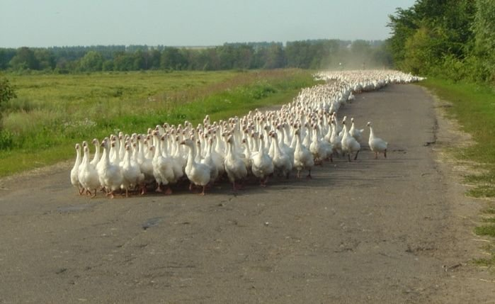Every year, countless agonising deaths occur through the pollution of rivers from factories or oil spillages at sea.  
This view has been expressed countless times in the past four centuries.  
There are countless arguments against this ridiculous proposal.  
Countless times when I needed someone to talk to, she would listen.

|  |
| --- |
| **country** |

What is the largest country in Europe?  
Sri Lanka is my native country, but I've been living in Belgium for the past five years.  
French cheeses are exported to many different countries.

|  |
| --- |
| **coup** |

Haiti’s first elected president was deposed in a violent military coup.  
He seized power in a military coup in 1977.  
There was an attempted coup against Togo’s military dictator.  
They were arrested and accused of plotting a coup against the government.  
He was imprisoned for his part in a coup plot against the regime.

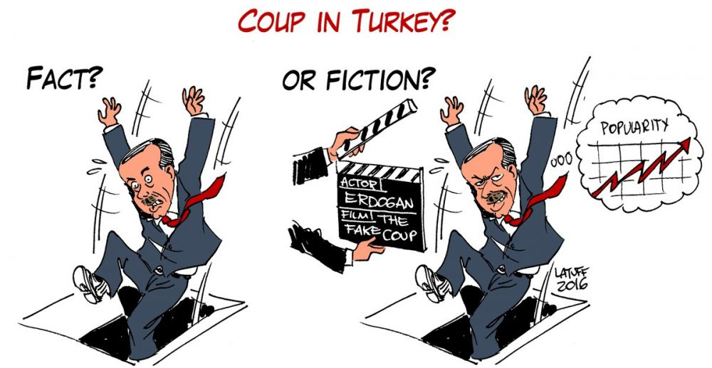

|  |
| --- |
| **coupling** |

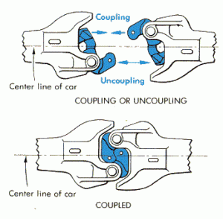***something that connects two things together, especially two vehicles***  
The carriage at the end of the train was left stranded when the coupling broke.

***when two things are joined or connected (SYN combination)***  
an attractive coupling of two Slavonic Dances  
The couplings between members of an ecosystem are far more flexible and transient than the couplings between members of an organism.

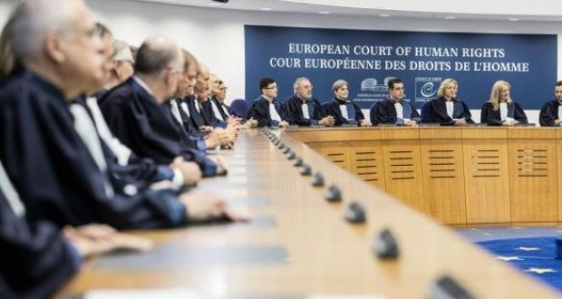***formal an act of having sex***

|  |
| --- |
| **court** |

The court case lasted six weeks.  
Four people will appear in court today, charged with fraud / cruelty to animals.  
You may be asked to give evidence before a court of law.  
Please describe to the court exactly what you saw.

Can you book a tennis court for tomorrow?

|  |
| --- |
| **cousin** |

My brother's wife and I both had babies around the same time, so the cousins are very close in age.  
Many of our distant cousins, whom we hadn't seen for years, came to my sister's wedding.

|  |
| --- |
| **cover** |

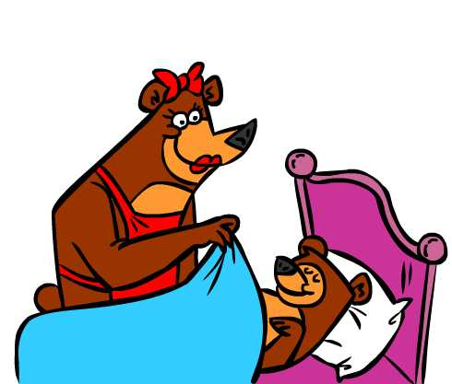The light was so bright that I had to cover my eyes.  
Snow covered the hillsides.  
She covered him (up) with a blanket.

I keep my computer printer under a protective plastic cover.  
Remove the packaging and pierce the plastic cover before microwaving.

*to do someone else's job or duty when they are absent:*

I'm going to the doctor's tomorrow, so do you think you could cover my shift for me?

|  |
| --- |
| **from cover to cover** |

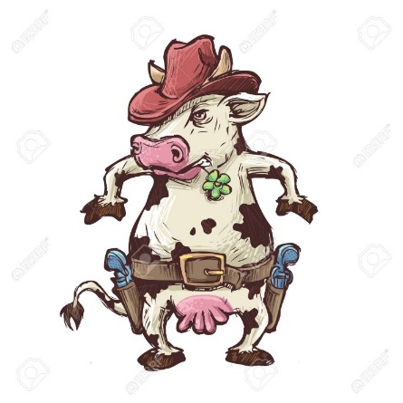*read sth from cover to cover*  
​  
to read a book, magazine, etc. all the way through from the beginning to the end

|  |
| --- |
| **cow** |

The farmer called the vet out to treat a sick cow.  
We watched the cow suckling her calves.  
The cows were grazing in the meadow.  
We visited a dairy farm and saw the cows being milked.

|  |
| --- |
| **cowboy** |

He was wearing cowboy boots and a cowboy hat.  
I don't much like cowboy films/movies.

|  |
| --- |
| **crab** |

We walked along the beach collecting small crabs.  
All the shops on the seafront had crab for sale.  
This crab meat/salad is delicious!

|  |
| --- |
| **cradle** |

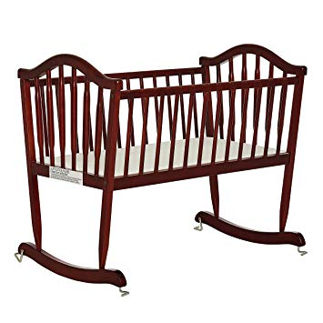*a small bed for a baby, especially one that moves from side to side:*

My mother rocked the cradle.

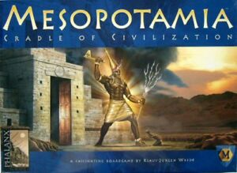

|  |
| --- |
| **cradle of civilization** |

Mesopotamia is often called "the cradle of civilization".

|  |
| --- |
| **create** |

It's important to create a good impression when you meet a new client.  
Please create a new folder there.  
The Bible and Quran say that God created the world.

|  |
| --- |
| **creepy** |

***making you feel nervous and slightly frightened***  
The house looked OK from the outside but inside it was all dark and creepy.  
Sometimes I have the creepy feeling that you will never get your documents in order.  
There’s something creepy about the way he looks at me. 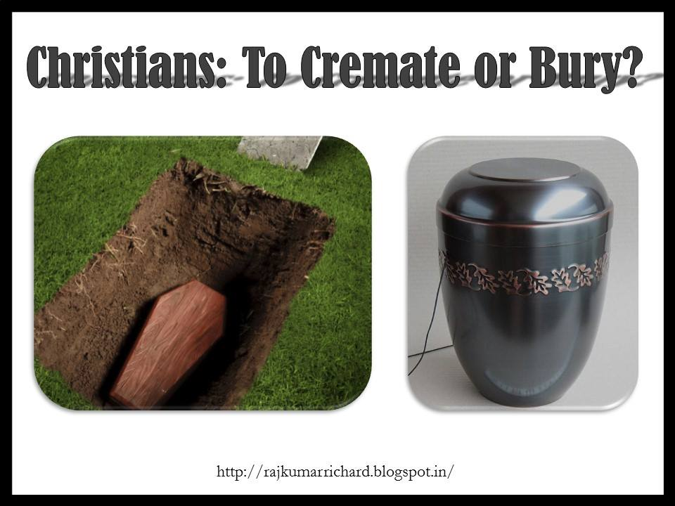

|  |
| --- |
| **cremate** |

***to burn a dead person's body, usually as part of a funeral ceremony***  
Then their bodies were cremated at night to conceal the evidence.  
Here, the dead were cremated to enable their souls to ascend to the light.

|  |
| --- |
| **crew** |

The aircraft has/carries a crew of seven.  
He is a member of our camera crew.  
Ambulance crews battled to rescue people trapped in the wreckage.  
The captain and crew would like to welcome you on board.  
The plane crashed, killing two of the crew and four passengers.

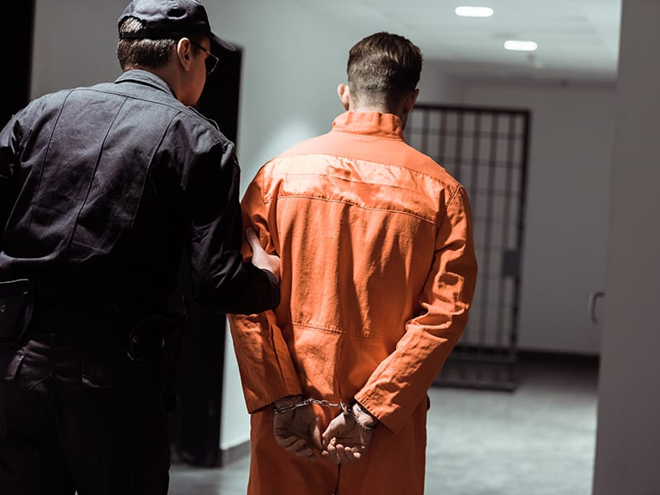

|  |
| --- |
| **criminal** |

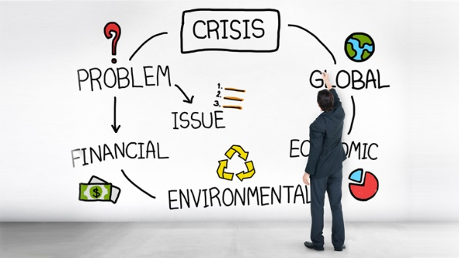The police officer told the criminal that he had the right to remain silent.  
If you spend any time in prison, you're labeled as a criminal **(sabıkalı)** for the rest of your life.  
I was sure he was involved in some kind of criminal activity.  
I think keeping animals locked up in cages is criminal.

|  |
| --- |
| **crisis** |

A crisis separates the real men from the pretenders.  
A mediator has been called in to resolve the crisis.

|  |
| --- |
| **critical** |

***if you are critical, you criticize someone or something***  
Many economists are critical of the government’s economic policies.  
He made some highly critical remarks.

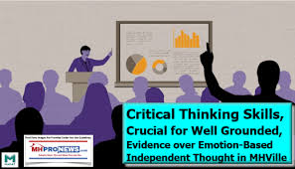***something that is critical is very important because what happens in the future depends on it***  
These talks are critical to the future of the peace process.  
It is absolutely critical for us to know the truth.  
Foreign trade is of critical importance to the economy.

|  |
| --- |
| **crocodile** |

Humans, dogs, elephants and dolphins are all mammals, but birds, fish and crocodiles are not.

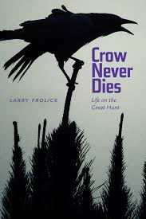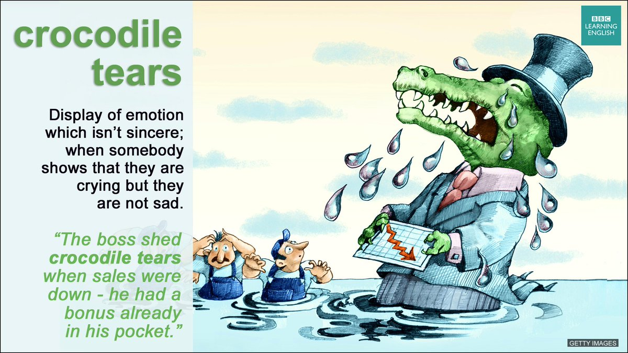

|  |
| --- |
| **crocodile tears** |

It is not enough for us to weep crocodile tears over this affair.

|  |
| --- |
| **crow** |

The cock/rooster started to crow.

a large, black bird with a loud, unpleasant cry

|  |
| --- |
| **crowd** |

Two's company, three's a crowd.  
A crowd had gathered to hear her speak.  
In her bright yellow coat, she was easily identifiable in the crowd.  
A big crowd of demonstrators were protesting against cuts in health spending.  
He pushed his way to the front of the crowd to get a better look.

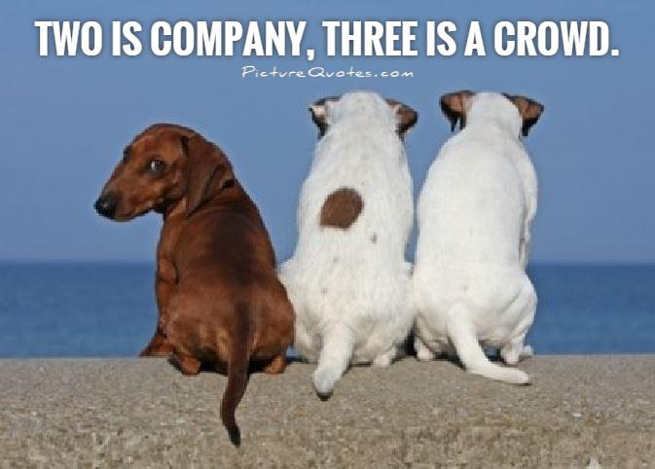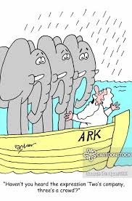

|  |
| --- |
| **crucial** |

Her work has been crucial to the project's success.  
It is crucial that the problem is tackled immediately.  
The price will be a crucial factor in the success of this new product.  
Parents play a crucial role in preparing their children for adult life.  
Good leadership is of crucial importance in motivating staff.



|  |
| --- |
| **cruel** |

*extremely unkind and unpleasant and causing pain to people or animals intentionally:*  
Don't tease him about his weight - it's cruel.  
Children can be very cruel to each other.

*extremely unkind and intentionally causing pain:*  
Her classmates made some cruel remarks.  
Is the death penalty cruel and unusual punishment?  
I think it’s cruel to put a dog in a cage.

|  |
| --- |
| **crumble** |

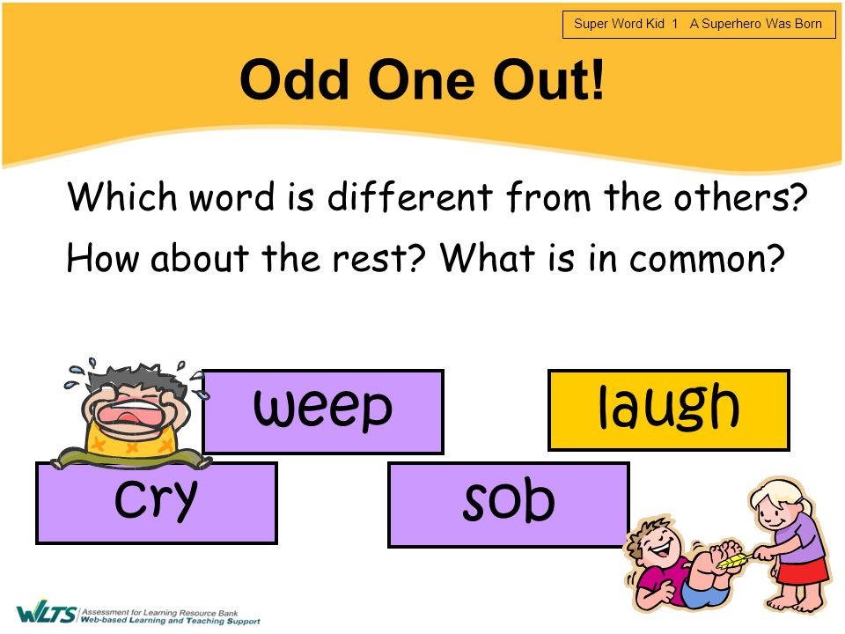*to break, or cause something to break, into small pieces:*  
She nervously crumbled the bread between her fingers.  
The cliffs on which the houses are built are starting to crumble.  
That old wall is starting to crumble.

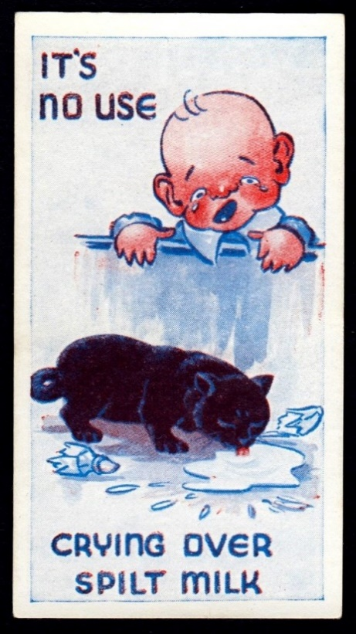*to become weaker in strength or influence:*  
Support for the government is crumbling.

|  |
| --- |
| **cry** |

I failed the exam, but it's no use crying over spilled milk. I'll try it again.

|  |
| --- |
| **crystal ball** |

I can read the crystal ball and tell you of your future.  
Let me look into the crystal ball. Hmm It is foggy..I see you.

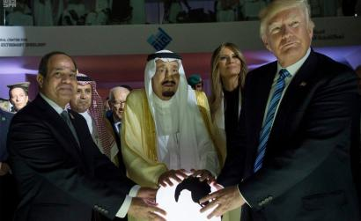

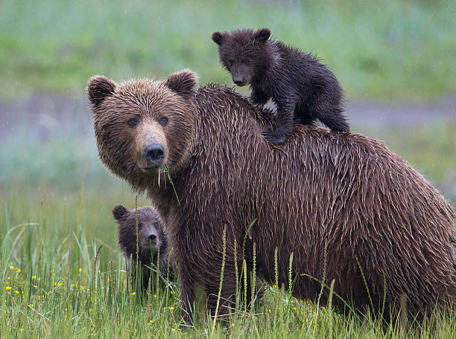

|  |
| --- |
| **cub** |

***the baby of a wild animal such as a lion or a bear***  
a five-month-old lion cub  
a tiger and her cubs

|  |
| --- |
| **curb** |

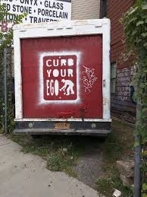***to control or limit something in order to prevent it from having a harmful effect***  
You really need to curb your spending.  
The police are trying to curb under-age drinking.  
We are trying to keep a curb on their activities.

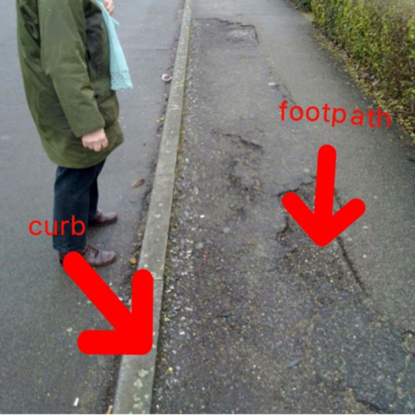***a raised edge along the side of a street, often forming part of a path for people to walk on:***  
She stood on the curb and waited until the light turned green to cross the street.

|  |
| --- |
| **curfew** |

**a law that forces people to stay indoors after a particular time at night, or the time people must be indoors**

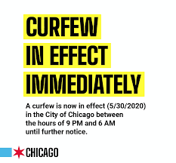The government imposed a night-time curfew throughout the country.  
The curfew was lifted (=ended) on May 6th.  
The whole town was placed under curfew.  
He was shot for breaking (= not obeying) the curfew.

|  |
| --- |
| **curiosity** |

**Just out of curiosity** I decided to go through the files.  
I know, there is a saying in English. **Curiosity killed the cat**..

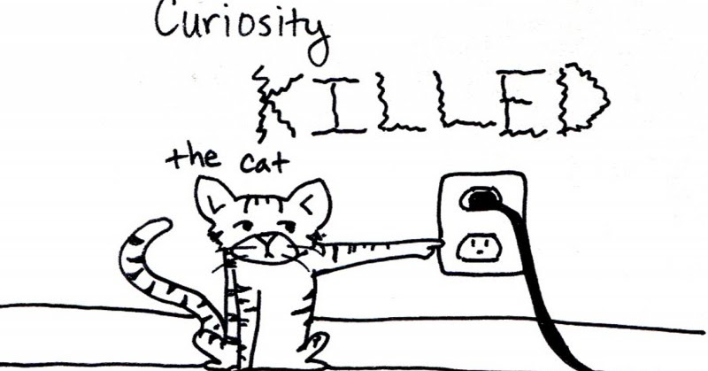

|  |
| --- |
| **curious** |

I was curious to know what would happen next.  
Babies are curious about everything around them.  
"Why did you ask?" "I was just curious."

|  |
| --- |
| **currently** |

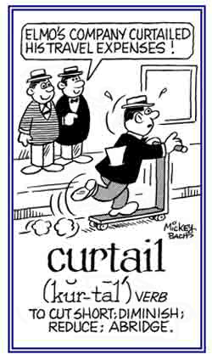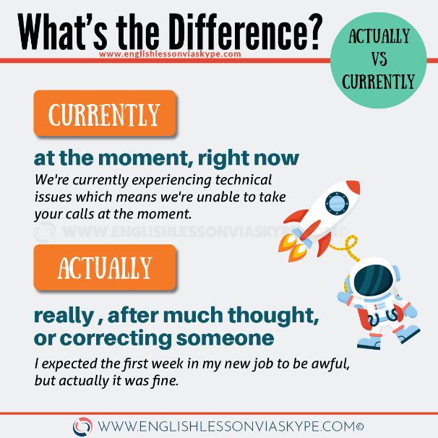***at the present time***  
He is currently working on his first novel.  
The Director is currently having talks in the US  
The device is currently available only in Japan.  
He currently holds the position of technical manager.

|  |
| --- |
| **curtail** |

***to reduce or limit something, or to stop something before it is finished:***  
He had to curtail his speech when time ran out.  
The Federal Reserve raised interest rates slightly to curtail inflation.  
The new law will curtail police powers.  
Then their freedom is curtailed, their choices limited and their frustrations increased.

|  |
| --- |
| **curtain** |

Ella drew the curtains and switched the light on.  
Shall I open the curtains?  
Would you mind opening the curtains?  
Before the curtain went up, the dancers took their places on stage.

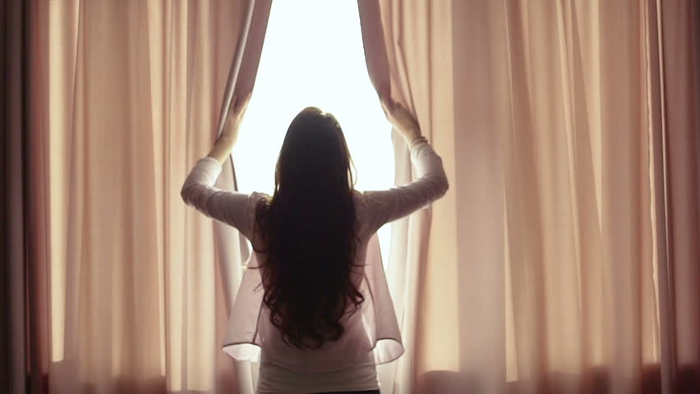

|  |
| --- |
| **custody** |

***the legal right or duty to care for someone or something, especially a child after its parents have separated or died:***  
The court awarded/granted/gave custody of the child to the father.  
The mother got/received custody of the child.

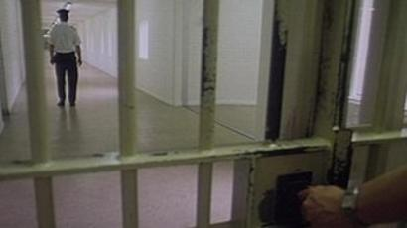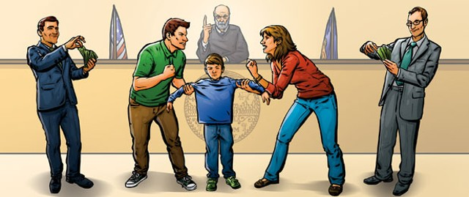

***the state of being kept in prison, especially while waiting to go to court for trial:***  
The suspect is now in custody.  
You will be remanded in custody until your trial.

|  |
| --- |
| **customer** |

Mrs Wilson is one of our regular customers.  
Would you mind waiting? I'm dealing with another customer at the moment.  
***"the customer is always right"***

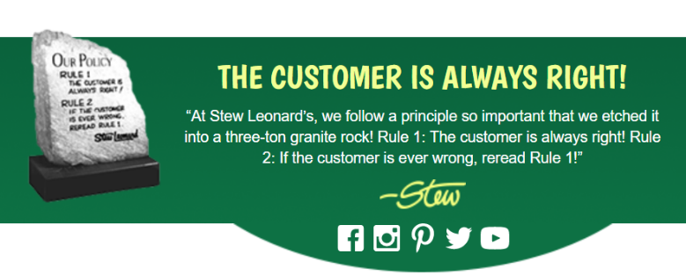

|  |
| --- |
| **customize** |

***to make or change something according to the buyer's or user's needs***  
General Motors will customize Cadillacs for special clients.  
Employees can customize the software to suit their needs.  
The basic design of the vehicle has been customized to the client's requirements.

|  |
| --- |
| **cut** |

Cut the meat up into small pieces.  
This knife doesn't cut very well.  
Where did you have your hair cut?  
I cut my finger chopping onions with that knife last night.  
Could you cut me a small piece of cheese, please?  
He cut the cake into six pieces.  
The razor slipped while he was shaving and he cut himself.

|  |
| --- |
| **cut off** |

***the act of stopping the supply of something:***

The US has announced a cutoff of military aid to the country.  
The US has threatened to cut off economic and military aid.

***a fixed point or level at which you stop including people or things: deadline***  
31 March is the cutoff date for applications to be accepted.

|  |
| --- |
| **cute : lovely** |

She was a really cute baby.  
Do you like Jill Anderson? I think she's cute!  
Heidi is the cutest girl in my class.

|  |
| --- |
| **cutting edge** |

***the most modern stage of development in a particular type of work or activity:***a company at the cutting edge of mobile communications technology  
The scientific and engineering skills which we have developed are at the cutting edge of nuclear technology.



***an advantage over other people or things***  
The team are relying on Gregg to give them a cutting edge.

|  |
| --- |
| **cynical** |

***unwilling to believe that people have good, honest, or sincere reasons for doing something***  
The public is cynical about election promises.  
Since her divorce, she's become very cynical about men.  
She has a pretty cynical view of men.  
I've always been deeply cynical about politicians.

